MAHARANI GIRLS ENGINEERING COLLEGE, JAIPUR

Department Of Electronics and CommunicationEngineering

LAB-MANUAL
IV Year VIII SEMESTER

8EC6A
INDUSTRIAL ECONOMICS & MANAGEMENT LAB

1

S.NO. | CONTENTS
1 | RTU Syllabus
2. | Vision and Mission
3. | PEOs
4. | POs
5. | Course outcomes
Exp. 1 | Overview of the economics and industrial economics  - Motives of the firm, industrial efficiency  - Theories of profitability, market structure  - Principles of costing
Exp. 2 | Understand the following concepts:  - Industrial location and productivity analysis  - Input-Output analysis and economic power  - New industrial policy 1991- critical analysis  - Entrepreneurship in industrial development
Exp. 3 | Overview of the project management and evaluation:  - Industry classification and legislations  - Recent trends in MNCs, FDI, LPG  - Capital budgeting techniques in project evaluation  - BEP
Exp. 4 | Understanding the basic concept of management:  - Principles of management  - Functions- planning, organizing  - Staffing, directing, co-ordinating  - Decision making

Exp. 5
Providing the knowledge of global practices current issues for following:
- TQM, JIT
- Quality circle, KANBAN, six sigma
• ISO 9000, 14000
- CRM

DETAILED SYLLABUS

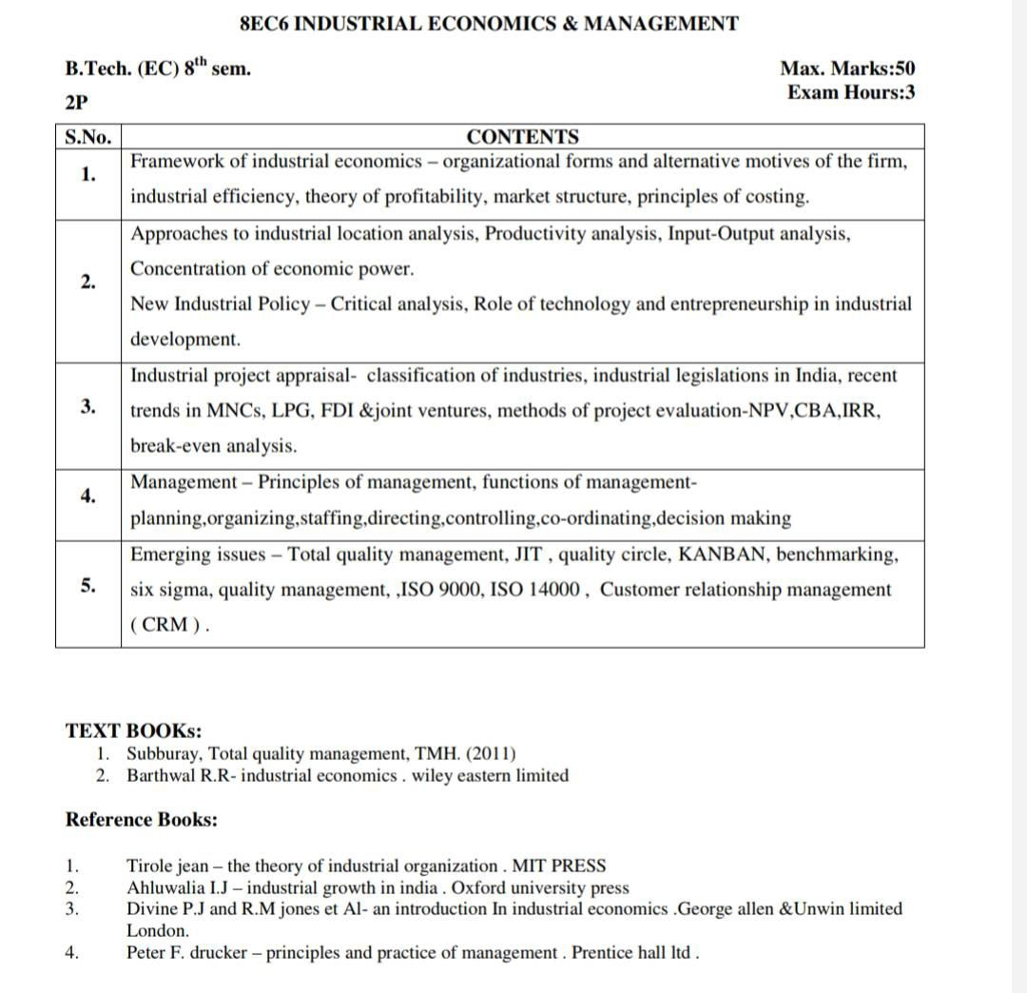

VISION AND MISSION

VISION

Create an Educational environment in which students are prepared to meet the challenges of modern Industrial society by equipping them with:
- Up to date Technical Knowledge
- Analytical and Practical skills
- A creative and innovative approach to work

MISSION

- To provide its students with knowledge required for high quality engineering process.
- To provide creativity, development activities, integration, sharing and applying knowledge about electronics and information technologies.
- To equip with a broad intellectual spectrum in order to prepare them for diverse and competitive carrier paths.

5

PROGRAM EDUCATIONAL OBJECTIVES (PEOs)

PEO1: To provide students with a strong foundation in the Electronics & Communication engineering fundamentals necessary to formulate, solve and analyze engineering problems and to prepare them for graduates studies, R&D, consultancy and higher learning.(Core Competence and Learning Environment)
PEO2: To build up skills to analyze the requirements of the electronics, understand the technical specifications, design and provide novel engineering solutions and efficient product design.
PEO3: To prepare graduates for a successful career, professional growth in core and allied sectors or as entrepreneurs so they can contribute to betterment of society.
PEO4: To give exposures of emerging technologies and opportunities to work as team on multidisciplinary projects with effective communication skills and leadership qualities.

PROGRAM OUTCOMES (POs)

PO1:- Ability to demonstrate knowledge in Mathematics, Science and Engineering by solving complex Electronics and Communication Engineering problems.

PO2:- Ability to identify and formulate design in Electronics or Communication system that meets the consumer specification.

PO3:- Ability to analyze and interpret data using research based knowledge in Electronics or Communication and provides significant conclusions.

PO4:- Ability to experiment with the modeling and simulation tools for analysis of Electronics and Communication Engineering problems and their limitations.

PO5:- Ability to apply reasoning and knowledge to assess global and societal issues.

PO6:- Ability to demonstrate the impact of Engineering and technological solutions for sustainable development of society and environment.

PO7:- Ability to Apply ethical principles and commit to professional ethics and responsibilities and norms of the engineering practice.

PO8:- Ability to understand individual role and leadership qualities to lead diverse groups in multidisciplinary fields.

PO9:- Ability to communicate effectively in both verbal and written forms among peers and society.

PO10:- Ability to develop leadership and management skills with best professional and economic concern for managing team or as an individual in multidisciplinary environment.

PO11:- Ability to be capable of self-education and clearly understand the value of lifelong learning

COURSE OUTCOMES

CO1: Understand major industrial economics tools so that the decisions regarding the profitability and the economics can be taken by the help of proper costing system. Overall concepts will help increase profitability of the business.

CO2: Explanation of major concepts of the production and cost analysis. Making them understand about the changes which happened after new industrial policy.

CO3: Develop understanding of practical evaluation part of project evaluation and concepts of joint venture FDI, MNCs etc.

CO4: Developing the knowledge of heart of organization- Management. Major principles of it and the major function viz. How to do planning? Organizing things, staffing, controlling and coordinating.

CO5: Discussing regarding the current issues of TQM, JIT, KANBAN, ISO, Six Sigma, CRM and benchmarking.

9

10

