MAHARANI GIRLS ENGINEERING COLLEGE, JAIPUR
AJMER ROAD, JAIPUR

LABORATORY ECL-11 LABORATORY MANUAL

SUBJECT: -POWER ELECTRONICS LAB SUBJECT CODE: -6EC4-24

DEPARTMENT OF ELECTRONICS & COMMUNICATION ENGINEERING

Vision of the Institute
To promote higher learning in advanced technology and industrial research to make our country a global player

Mission of the Institute
To promote quality education, training and research in the field of Engineering by establishing effective interface with industry and to encourage faculty to undertake industry sponsored projects for students

Quality Policy of the Institute

“We are committed to „achievement of quality‟ as an integral part of our institutional
policy by continuous self-evaluation and striving to improve ourselves.”

Institute would pursue quality in:

- All its endeavors like admissions, teaching-learning processes, examinations, extra and co-curricular activities, industry-institute interaction, research & development, continuing education and consultancy.
- Functional areas like teaching departments, Training and placement cell, library, administrative office, accounts office, hostels, canteen, security services, transport, maintenance section and all other services.

Vision and Mission

Vision of the Department: To make the Department a “Center of Excellence” in
electronics and communication engineering
Mission of the Department: To provide the students an environment for understanding basics of Electronics and Communication Engineering, and to prepare the students for their professional careers.

Program Educational Objectives (PEOs)
  - The graduates will be able to pursue successfully in the relevant fields and advance in their profession.
  - The graduates may excel in pursuing higher education and life-long learning.
  - Graduates will be able to hold high ethical standards and work effectively in multidisciplinary teams with strong management and team work skills.

Program Outcomes (POs)
- Engineering knowledge: Apply knowledge of mathematics, science, and engineering fundamentals, and an engineering specialization to the solution of complex engineering problems.
- Problem Analysis: Identify, formulate, review research literature and analyze complex engineering problems reaching substantiated conclusions using first principles of mathematics, nature science, and engineering sciences.
- Design/Development of Solution: Design solutions for complex engineering problems and design system components or processes that meet the specified needs with appropriate consideration for the public health and safety, and the cultural, societal, and environmental consideration.
- Conduct Investigations of Complex Problem: Use research-based knowledge and methods to conduct experiments, analysis and interpretation of data, and synthesis of the information to provide valid conclusions.
- Modern tool usage: Cerate, select, and apply appropriate technique, resources, and modern engineering and IT tool including predication and modeling to complex engineering activity with an understanding of the limitations.
- The engineer and society: Apply reasoning informed by the contextual knowledge to assess societal, health, safety, legal and cultural issues and the consequent responsibility relevant to the professional engineering practices.

II | P a g e

- Environment and Sustainability: Understand the impact of the professional engineering solutions in societal and environmental context, and demonstrate the knowledge of, and need for sustainable development.
- Ethics: Apply ethical principles and commit to professional ethics and responsibilities and norms of the engineering practice.
- Individual and team work: Function effectively as an individual, or leader and as a member or leader in diverse teams, and in multidisciplinary settings.
- Communication: Communicate effectively on complex engineering activities with the engineering community and with society at large, such as, being able to comprehend and write effective reports and design documentation, make presentations, and give and receive clear instructions.
- Project management and finance: Demonstrate knowledge and understanding of the engineering and management principles and apply theses to one‟s work, as s member and leader in a team, to manage projects and in multidisciplinary environments.
- Life-long learning: Recognize the need for, and have the preparation and ability to engage in independent and life-long learning in the broadest context of technological change.

Program Specific Outcomes(PSO’s)
  - Apply the skills of communication technology in the design and implementation of engineering systems.
  - Design and develop microelectronics, VLSI and embedded systems for solving real life problems.
  - Use the knowledge of softwares and circuit designing for industrial applications.

Course Outcome:
CO 1: Understand the characteristics of SCR and its triggering using R , RC and UJT triggering circuits.
CO2: Understand AC voltage regulators using triac, antiparallel Thyristors and tries & disc as well as pulse generation using DSP/FPGA platform.
CO3: Study single-phase bridge converter, single-phase cycloconverter and single-phase dual converter along with dc motor speed control.
CO4: Perform experiment on single phase PWM inverter, buck, boost and buck-

boost regulators.
CO5: Perform speed control of a DC motor using a chopper and induction motors using single phase AC voltage regulator along with open loop & closed loop motor control

.6. Mpping of course Outcomes with Pos:

CO | PO 1 | PO 2 | PO 3 | PO 4 | PO 5 | PO 6 | PO 7 | PO 8 | PO 9 | PO1 0 | PO1 1 | PO1 2
CO 1 | 3 | 2 | - | 1 | 1 | 1 | 1 | - | 1 | - | 1 | 2
CO 2 | 3 | 2 | 1 | 2 | - | 2 | 2 | - | 2 | 1 | 2 | 2
CO 3 | 3 | 1 | 1 | 1 | - | 1 | 1 | - | 1 | - | 1 | 1
CO 4 | 3 | 2 | 2 | - | 1 | 2 | 2 | - | 2 | 1 | 3 | 3
CO 5 | 3 | 1 | 1 | 1 | - | 2 | 2 | - | 2 | 1 | 2 | 3
3: Strongly 2: Moderate 1: Weak

7. Mapping of Course Outcomes with PSOs:

CO | PSO1 | PSO2 | PSO3
CO 1 | - | 1 | 2
CO 2 | 2 | 1 | 2
CO 3 | - | - | 3
CO 4 | - | - | 3
CO 5 | - | - | 3

Lab Ethics:

DO’S

- Student should get the record of previous experiment checked before starting the new experiment.
- Read the manual carefully before starting the experiment.
- Before starting the experiment, get circuit diagram checked by the teacher.
- Before switching on the power supply, get the circuit connections checked.
- Get your readings checked by the teacher.
- Apparatus must be handled carefully.
- Maintain strict discipline.
- Keep your mobile phone switched off or in vibration mode.
- Students should get the experiment allotted for next turn, before leaving the lab.

DON’TS

- Do not touch or attempt to touch the mains power supply wire with bare hands.
- Do not overcrowd the tables.
- Do not tamper with equipment‟s.
- Do not leave the lab without permission from the teacher.

Safety Measures
  - Avoid direct contact with any voltage source and power line voltage. (Otherwise, and such contact may subject you to electrical shock).
  - Use insulating materials while working on electrical equipment.
  - Ensure that the power is OFF before you start connecting up the circuit. (Otherwise you will be touching the live parts in the circuit).
  - Check power chords for any sign of damage and be certain the chords use safety plugs and do not defeat the safety feature of these plugs by using ungrounded plugs.
  - When using connection leads, check for any insulation damage in the leads and avoid such defective leads.
  - Do not defeat any Safety devices such as fuse or circuit breaker by shorting across it. Switch on the power to your circuit and equipment only after getting them checked up and approved by the staff member.


Swami Keshvanand Institute of Technology Management and Gramothan

RTU Syllabus
Subject Name/code: Power Electronics Lab /6EC4-24 Practical hrs - 2
Class:B.Tech. III Yr. VI Sem. Branch: ECE
External Marks: 20 Internal Marks: 30 Total Marks: 50 Syllabus
S.No. | List of Experiments
1 | Study the characteristics of SCR and observe the terminal configuration, Measure the breakdown voltage, latching and holding current. Plot V-I characteristics.
2 | Perform experiment on triggering circuits for SCR. i.e. R triggering, R-C triggering and UJT triggering circuit.
3 | Study and test AC voltage regulators using triac, antiparallel thyristors and triac&diac.
4 | Study and obtain the waveforms for single-phase bridge converter.
5 | Perform experiment on single phase PWM inverter.
6 | Perform experiment on buck, boost and buck-boost regulators.
7 | Control speed of a dc motor using a chopper and plot armature voltage versus speed characteristic.
8 | Control speed of a single-phase induction motor using single phase AC voltage regulator.
9 | - Study single-phase dual converter.  - . Study speed control of dc motor using single-phase dual converter.
10 | Study single-phase cyclo converter.
11 | Perform experiment on Motor control – open loop & closed loop
12. | Design, observe and perform experiment on various type of pulse generation from DSP/ FPGA Platform. Perform experiment for PWM inverters and choppers.

Known gaps in curriculum via based PEOs and Outcomes:
Syllabus provided by RTU is good enough but there some missing topics that students need to fully understand the subject. So to fill that gap, below mentioned topics are discussed in the class.

Experiments beyond RTU syllabus:
- Study and obtain the characteristic of DIAC
- Study and obtain the waveform for single phase half wave controlled convertor

Mapping of beyond syllabus experiments with POs:

Beyond syllabus | PO1 | PO2 | PO3 | PO4 | PO5 | PO6 | PO7 | PO8 | PO9 | PO10 | PO11 | PO12
1 | 2 | 1 | 1 | 1 | - | - | - | - | 2 | 1 | 1 | 2
2 | 2 | 1 | 2 | 2 | - | - | - | - | 2 | 1 | 2 | 2

S.NO. | LIST OF CONTENTS |  | Page No.
1. | Program Educational Objectives (PEO‟S), PO‟S & CO‟S and their  mapping. |  | I-X
2. | List of Experiments
Exp: 1 | Study the characteristics of SCR and observe the terminal configuration, Measure the breakdown voltage, latching and holding current. Plot V-I characteristics. |  | 1-7
Exp: 2 | Perform experiment on triggering circuits for SCR. i.e. R-triggering, C- triggering and UJT triggering circuit. |  | 8-16
Exp: 3 | Study and test AC voltage regulators using TRIAC, Antiparallel Thyristors and TRIAC & DIAC. |  | 17-22
Exp:4 | Study and obtain the waveforms for single-phase bridge converter. |  | 23-30
Exp:5 | - ) Study operation of single-phase inverter.  - Study operation of three types of Pulse Width Modulation (PWM) techniques used in single phase inverter.  - Trace the output voltage, carrier signal, reference signal and both gate signal using single PWM of single-phase inverter. |  | 30-37
Exp:6 | To observe and verify the operation of buck, boost and buck-boost regulators. |  | 38-45
Exp:7 | To control speed of a DC motor using a chopper and plot armature voltage versus speed characteristic. |  | 45-50
Exp:8 | To control speed of a single-phase induction motor using single phase AC voltage regulator. |  | 50-53
Exp:9 | - To obtain the output waveforms for single phase dual converter using R and L loads  - Study speed control of DC motor using single phase dual converter. |  | 54-59
Exp:10 | To verify the operation of single phase Cyclo Converter with R and RL Loads and to observe the output and input waveforms. |  | 59-66
Exp:11 | Perform experiment on Motor control – open loop &closed loop using PID Controller |  | 67-70
Exp:12 | Design, observe and perform experiment on various type of pulse generation from DSP/ FPGA Platform. Perform experiment for PWM inverters and choppers. |  | 71-74
Beyond Syllabus:
Exp:13 |  | Study and obtain the characteristic of DIAC | 75-77

Exp:14 | Study of single phase half wave controlled rectifier using R- load and RL  – load. | 78-82

EXPERIMENT NO. 1

AIM:-

Study the characteristics of SCR and observe the terminal configuration, Measure the breakdown voltage, latching and holding current. Plot V-I characteristics.

APPARATUS REQUIRED:-

Power project Board

THEORY:-

SCR is a four layer, three junctions; p-n-p-n semiconductor switching device. It is unidirectional device. It has three terminals: anode, cathode and gate. Fig 1.1 (a) gives the constructional details of a typical SCR. It has four layers of alternate p-type and n-type silicon semiconductors forming three junctions J1, J2 and J3 as shown in fig 1.1 (a). The threaded portion is for the purpose of tightening the SR to frame or heat sink with the help of nut. Gate terminal is usually kept near the cathode terminal. The Schematic diagram and circuit symbol for a SCR are shown respectively in Fig 1.1 (b) and (c). The terminal connected to outer p region is called anode (A), the terminal connected to outer n region is called cathode and that connected to inner p region is called the Gate (G).
An SCR is so called because silicon is used for its construction and its operation as a rectifier (very low resistance in forward conduction and very high resistance in the reverse direction) can be controlled. It can be made to conduct in forward direction by applying positive voltage between anode-cathode terminals and making gate terminal positive with respect to cathode terminal. There is some maximum forward blocking voltage VBO, above which the SCR break- down and starts conducting in forward direction without need for any gate current. SCR also breakdowns in reverse direction when a certain maximum reverse voltage is exceeded, this voltage is called VBR. This reverse breakdown is destructive and hence should not be tried.

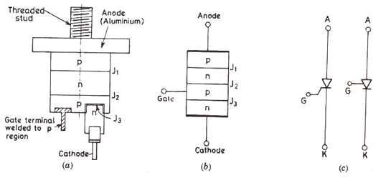

Fig 1.1 (a) Constructional details (b) Schematic diagram and (c) Circuit Symbol of a SCR

Once the SCR is conducting a forward current, the reverse junction no longer exists. No gate current is required for the device to remain in on-state. If the gate current is removed, the conduction of current from anode to cathode remains unaffected. If gate current is reduced to zero before rising anode current attains a value called the latching current, the SCR will turn-off again. The gate pulse width should be chosen judiciously to ensure that anode current rises above the latching current. Latching current (IL):- defined as the minimum value of anode current which is must attain during turn-on process to maintain conduction when gate signal is removed.
Once the SCR is conducting, gate loses control. The SCR can be turned off only if forward current falls below a low-level current called the holding current. Holding current (IH) :- defined as the minimum value of anode current below which is must fall for turning-off the SCR.
Latching current is higher than holding current. IL is associated with turn-on process and IH with turn-off process.

Static V-I Characteristics of a SCR Reverse Blocking Mode:
When cathode is made positive with respect to anode with switch S open, Fig 1.2 (a) SCR is reverse biased as shown in Fig 1.3 (a); junction J1, J3 are seen to be reverse biased whereas junction J2 is forward biased. The device behaves as if two diodes are connected in series with reverse voltage applied across them. A small leakage current of the order of few milliamperes flows. This is reverse blocking mode, called the off-state, of the SCR. If the reverse voltage is increased, then at a critical breakdown level, called reverse breakdown voltage VBR, an avalanche occurs at J1 and J3 and the reverse current increased rapidly. A large current associated with VBR gives rise to more losses in the SCR. This may lead to SCR damage as the junction temperature may exceed its permissible temperature rise. It should therefore, be ensured that maximum working reverse voltage across a SCR does not exceed VBR.

Forward Blocking Mode:

When anode is positive with respect to the cathode, with gate circuit open, SCR is said to be forward biased as shown in Fig 1.3 (b). Junction J1, J3 are forward biased but junction J2 is reverse biased. In this mode, a small current, called forward leakage current, flows as shown in Fig 1.2 (b). In case the forward voltage is increased, then the reverse biased junction J2 will have an avalanche breakdown at a voltage called forward breakover voltage (VBO). When forward voltage is less than VBO, SCR offers high impedances. Therefore, a SCR can be treated as an open switch even in the forward blocking mode.

Fig 1.2 (a) Elementary circuit for obtaining SCR V-I Characteristics
(b) Static V-I Characteristics of a SCR
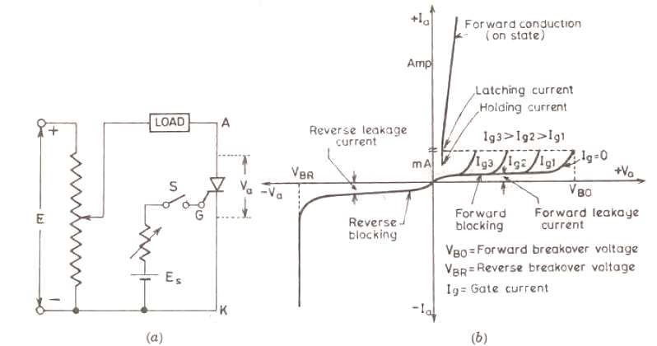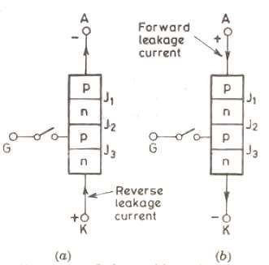

Fig 1.3 (a) J2 forward biased and J1, J3 reverse biased
(b) J2 reverse biased and J1, J3 forward biased

Forward Conduction Mode:

In this mode, SCR conducts currents from anode to cathode with a very small voltage drop across it. It is brought from forward blocking mode to forward conduction mode by turning it on by exceeding the forward breakover voltage or by applying a gate pulse between gate and cathode. In this mode, SCR is in on-state and behaves like a closed switch. Voltage
drop across SCR in on-state is of the order of 1 to 2 V depending upon the rating of SCR. This

voltage drop increases slightly with an increase an anode current as shown in Fig 1.2 (b). In conduction mode, anode current is limited by load impedance alone as voltage drop across SCR is quite small. This small voltage drop (VT) across the device is due to ohmic drop in the four layers.

Circuit Diagram

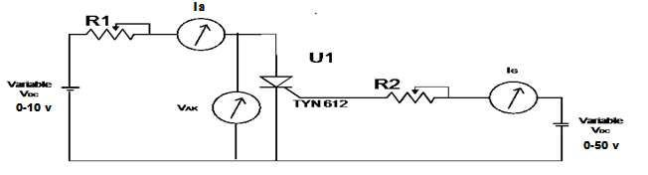
Fig 1.4 Circuit diagram for SCR for obtaining V-I Characteristics

PROCEDURE:
- Refer to SCR CHARACTERISTICS section of the ckt. Board.
- Select any one SCR from the four SCR present on the project board. Connect Voltmeter (0-50V D. C.) across A1-K1, positive terminal to A1 and negative terminal to K1.
- Connect the negative terminal of milliammeter (20mA/200 mA D. C.) to A1 of SCR and positive terminal to Resistance.
- Connect other end of selected resistance to the positive terminal of DC supply (0-50V). Connect the negative terminal to K1 of Selected SCR.
- Connect 0-10V D.C. Power supply with Positive terminal to another resistance and negative terminal to K1.
- Connect the other terminal of resistance to positive terminal to another Ammeter.
- Connect the negative terminal to gate (G1) of SCR.
- Switch ON the unit.
- Gate current (IG) can be adjusted varying 0-10 V D. C. Voltage supply.
- Slowly increase anode voltage (VA) by varying 0-50V variable source and take reading of VA and Anode current IA. Carefully observe the point at which SCR starts conducting

(VBO). Once maximum current IA is reached start decreasing the O/P voltage till SCR just turns OFF. Note down anode current IA at this point, this is value of holding current IH.
- Repeat the step 9 for three more values of gate current IG. Take readings as shown in Table. Each time note down forward break-down voltage VBO.

OBSERVATION:-

S. No. | IG = |  | IG = |  | IG = |  | IG =
 | VA (V) | IA (mA) | VA (V) | IA (mA) | VA (V) | IA (mA) | VA (V) | IA (mA)
1.
2.
3.
4
5.
6.

CHARACTERISTICS CURVE
Plot graph of VA v/s IA for different values of IG.

Fig. 1.5 V-I Characteristics curve of SCR

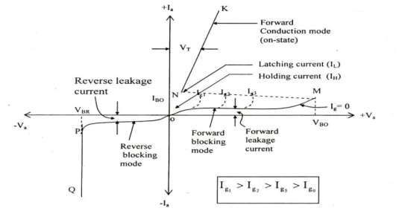

RESULT:-
Characteristics of SCR were studied and plot the graph from the reading.

Latching Current = …………mA Holding Current = ……….. mA Break down voltage = ……… V
As we increase the value of gate current the value of its breakover voltage decreases and SCR starts to conduct at lower voltage value. When SCR comes to sufficient or proper conduction mode then even if we disconnect the gate circuitry SCR keeps on conducting till we reduce its gate current beyond the holding current.

DISCUSSION:-
    - What is a thyristor? Give its constructional details and Sketch its schematic diagram.
    - Describe the different modes of operation of a SCR.
    - Draw the static V-I characteristics of SCR. Analyze different points on the characteristics.
    - Define latching and holding current for SCR.
    - Justify the statement, “Higher the gate current, lower is the forward breakover voltage”.
    - Compare diode and SCR.
    - What are the requirements to turn on SCR?

AIM:-
EXPERIMENT NO. 2

Perform experiment on triggering circuits for SCR. i.e. R-triggering, C- triggering and UJT triggering circuit.

APPARATUS REQUIRED:-

      - Power project board

      - 20MHz Oscilloscope

THEORY:-

The most common method for controlling the conduction in an SCR is by means of the gate voltage control. The gate control circuit is also called firing or triggering circuit. These gating circuits are usually low-power electronic circuits.
A firing circuit should fulfill the following two functions:-

- If circuit has more than one SCR, the firing circuit should produce gating pulses for each SCR at the desired instant for proper operation of the circuit. These pulses must be periodic in nature..
- The control signal generated by a firing circuit may not be able to turn-on an SCR.

RESISTANCE FIRING CIRCUITS:-
Resistance triggering circuits are the simplest and most economical. They however, suffers from a limited range of firing angle control (0° to 90°), great dependence on temperature and difference in performance between individual SCRs. Fig.2.1 shows the most basic resistance triggering circuit. R2 is the variable resistance, R is the stabilizing resistance. In case R2 is zero, gate current may flow from source, through load, R1, D and gate to cathode. This current should not exceed maximum permissible gate current Igm. R1 can therefore, be found from the relation-
Vm / R1 ≤ Igm or R1 ≥ Vm / Igm

Where, Vm = maximum value of source voltage.

a b
LOAD
Vo i1

R1

R2
Vs = Vm.Sin wt
D VT

R
Vg

Fig. 2.1- R-triggering circuit

Resistance R should have such a value that maximum voltage drop across it does not exceed maximum possible gate voltage Vgm. This can happen only when R2 is zero. Under this condition, Vm . R / (R1 + R) ≤ Vgm
R ≤ Vgm. R1 / (Vm – Vgm)
As resistance R1, R2 are large, gate trigger circuit draws a small current. Diode allows the flow of current during positive cycle only i.e. gate voltage is half-wave dc pulse. The amplitude of this dc pulse can be controlled by varying R2. The potentiometer setting R2 determines the gate voltage amplitude.

When R2 is large, current i is small and the voltage across R, i.e. vg = iR is also small as shown in Fig.2.2 (a) .As Vgp (peak gate voltage) is less than Vgt (gate trigger voltage), SCR will not turn on. Therefore, load voltage vo=0, io = 0 and supply voltage vs appears as vT across SCR as shown in Fig 2.2 (a)

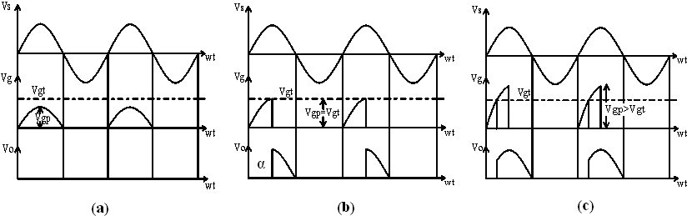

Fig. 2.2 Resistance firing of an SCR in a half wave circuit with dc load-
  - No triggering of SCR, (b) α = 90°, (c) α < 90°.
In Fig 2.2 (b) R2 is adjusted such that Vgp = Vgt. This gives value of firing angle as 90o. In Fig
2.2 (c) Vgp > Vgt as soon as vg becomes equal to Vgt for the first time SCR is turned on. The resistance triggering cannot give firing angle beyond 90o. Increasing vg above Vgt turns on the SCR at firing angle less than 90o. When vg reaches Vgt, SCR fires, gate loses control and vg is reduced to almost zero value.

A relationship between peak gate voltage Vgp and gate trigger voltage Vgt may be expressed as follows:

Vgp sin α = Vgt
α = sin-1 (Vgt / Vgp) Vgp= Vm R /(R1 + R2 +R)
α = sin-1 (Vgt . / (R1 + R2 +R) ) / VmR
Vgt, R1, R and Vm are fixed, α is proportional to sin-1 (R2) or α is proportional to R2 .This shows that firing angle is proportional to R2. A R2 is increased from small value, firing angle increases. α Can never be more than 90o.

RC-FIRING CIRCUIRS-
The limited range of firing angle control by resistance firing circuit can be overcome by RC firing circuit. There are several variations of RC trigger circuits.

RC HALF-WAVE TRIGER CIRCUIT:

As Fig 2.3 illustrates RC half wave trigger circuit. By varying the value of R, firing angle can be controlled from 0° to 180°.

Fig 2.3 RC half wave trigger circuit

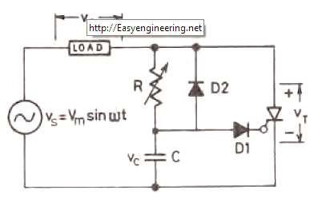
In the negative cycle, capacitor C charges through D2 with lower plate positive to peak supply voltage Vm at ωt = -90°. During the period of ωt = -90° to ωt = 0°, capacitor voltage vc may fall from –Vm at ωt = -90° to some lower value –oa at ωt = 0° as shown in Fig. 2.4. As the SCR anode voltage passes through zero and becomes positive, C begins to charge through variable resistance R from the initial voltage –oa. When capacitor charges to positive voltage equal to gate trigger voltage Vgt, SCR is fired and after this, capacitor holds to a small positive voltage. Diode D1 is used to present the breakdown of cathode to gate junction through D2 during negative half cycle. The range of power frequencies is given by-
RC ≥ 1.3T / 2 ≈ 4 / ω

T = 1 / f = period of ac line frequency in second
The SCR will trigger when Vc = Vgt + Vd, where Vd is the voltage drop across diode D1. The maximum value of R is given by-

Vs ≥ RIgt + Vc
Vs ≥ RIgt + Vgt + Vd
R ≤ (Vs – Vgt - Vd) / Igt Where, vs = source voltage at which SCR turns on

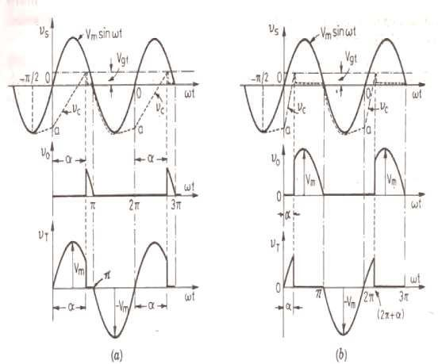
Fig 2.4 Waveforms for RC half-wave trigger circuit
  - High value of R (b) low value of R

C) UJT TRIGERRING-

R and RC triggering circuits described above give prolonged pulses. As a result power dissipation in the gate circuit is large. At the same time, R and RC triggering circuits cannot be used for automatic or feedback control systems. These difficulties can be overcome by the use of UJT triggering circuits. The unijunction transistor is a highly efficient switch; its switching time is in the range of nanoseconds. Since UJT exhibits negative resistance characteristics, it can be used as a relaxation oscillator. Fig. 2.5 (a) shows a circuit diagram

with UJT working in the oscillator mode. The external resistances R1, R2 are small in comparison with the internal resistances. RB1, RB2 of the UJT bases. The charging resistances R should be that its load line intersects the device characteristics only in the negative resistance.

In fig. 5(a), when source voltage VBB is applied, capacitor C begins to charge through R exponentially towards VBB. During this charging, emitter circuit of UJT is an open circuit. The capacitor voltage VC, equal to the emitter voltage Ve is given by-
VC = Ve = VBB (1 – e-t/RC)

The time constant of the charge circuit is τ1 = RC.

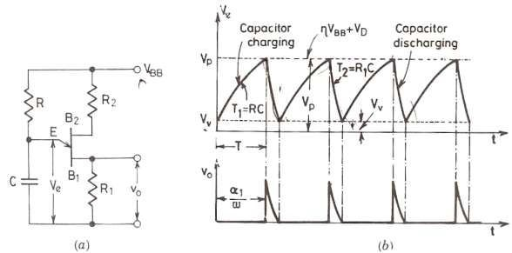

Fig. 2.5 UJT oscillator (a) Circuit diagram, (b) Voltage waveform.

When this emitter voltage Ve (or VC) reaches the peak point voltage Vp = (η VBB + VD), the unijunction between E-B1 breaks down. As a result, UJT turns on, and capacitor C rapidly discharges through low resistance R1 with a time constant τ2 = R1C. Here τ2 is smaller than τ1. When the emitter voltage decays to the valley point voltage VV, UJT turns off. The time T required for capacitor C to charge from initial voltage VV to peak point voltage VP, through large resistance R, can be obtained as under-

VP = ηVBB + VD = VV + VBB (1 – e-T/RC) VD = VV, η = (1 – e-T/RC)
T = 1/f = RC In (1 / (1-η))= 2.3 R1C1 log (1-η)
In case T is taken as the time period of output pulse duration (neglecting small discharge
time), then the value of firing angle α is given by-

α1 = ωT = ωRCIn (1/ (1- η)) Where ω is the angular frequency of UJT oscillator.
The potential of eta point A is ηVBB. But that of emitter is VV which is less than ηVBB, as a result E-B1unijunction is reverse biased and ceases to conduct, the UJT turns-off and goes into blocking mode. Capacitor C now again charge from Ve = VVto voltage ηVBB + VD, E- B1unijunction breaks down and the above cycle repeats.

PROCEDURE:

For Resistor triggering Circuit:-
  - Make the circuit connection as shown in Fig. 2.1
  - Now connect the CRO Probes across the load.
  - Vary the variable resistor R2 and because of this variation in R2 firing Angle of SCR varies. Now observe the variation in load voltage with respect to variation in firing angle.
  - Now connect the CRO Probes across the SCR.
  - Vary the variable resistor R2 and because of this variation in R2 firing Angle of SCR varies. Now observe the variation in voltage across SCR with respect to variation in firing angle.

For Resistor triggering Circuit:-
  - Make the circuit connection as shown in Fig. 2.3
  - Now connect the CRO Probes across the load.

  - Vary the variable resistor R2 and because of this variation in R2 firing Angle of SCR varies. Now observe the variation in load voltage with respect to variation in firing angle.
  - Now connect the CRO Probes across the SCR.
  - Vary the variable resistor R2 and because of this variation in R2 firing Angle of SCR varies. Now observe the variation in voltage across SCR with respect to variation in firing angle.

UJT Triggering Circuit:-
  - For UJT Triggering Circuit connect the positive terminal of 50 volt AC source to one terminal of load and negative terminal of source to cathode K1 of SCR 1.
  - Another terminal of load is connected to the anode A1 of SCR 1.
  - Now connect the G1 of UJT firing circuit to G1 of SCR and K1 of UJT firing circuit to K1 of SCR.
  - Now connect the CRO Probes across the load.
  - Now vary the firing angle of SCR using knob provided in UJT firing Circuit and observe the variation in load voltage with respect to variation in firing angle.
  - Now connect the CRO Probes across the SCR.
  - Now vary the firing angle of SCR using knob provided in UJT firing Circuit and observe the variation in voltage across SCR with respect to variation in firing angle.

RESULT:-
We have studied, plotted waveforms for the firing circuits for SCR- R, RC and UJT firing circuits.
We observed firing schemes of R, R-C and UJT firing circuits. There was a drawback in R triggering CKT that firing angle variation is limited in between 0 and 90o. This drawback can be eliminated in R-C firing circuit where we can vary the value of firing angle anywhere in between the 0 and 180o. Further in this type of firing circuit speed of firing is limited because of charging and discharging of capacitor. So for high frequency circuit we use UJT firing circuit.

DISCUSSION:-
- What is firing circuit?
- What are the limitations of R triggering circuit?
- How can angle of conduction changes in SCR?
- How is SCR turned off?
- What are the different turn on methods of SCR?
- What do you understand by firing angle?

EXPERIMENT NO.3

AIM:-

Study and test AC voltage regulators using TRIAC, Antiparallel Thyristors and TRIAC & DIAC.

APPARATUS REQUIRED:-

      - Power Project Board

      - CRO 20 MHz

THEORY:-

AC voltage regulator (controller) is a device which converts fixed alternating voltage to variable Alternating voltage without changing frequency. By connecting a reverse parallel pair of thyristors, DIAC or TRIAC between AC supply and load, the applied Load can be controlled. This type of power controller is known as AC voltage controller or AC regulators. The firing of a TRIAC can be phase controlled. Since DIAC exercised in both directions the power in the load can be varied from full value to almost zero. The DIAC in the circuit gives a wide range of symmetrical firing of the TRIAC. The resistance R1 control the Gate current by controlling the voltage across C. Here the voltage across C first turns on the DIAC which in turns applies enough voltage to the Gate to turn on the TRIAC. By property matching the DIAC to the TRIAC symmetrical triggering of the TRIAC in both the positive and negative alternations is accomplished. Moreover, the range of firing control is much wider so that a turn on delay of
almost 1800 is possible in each alternation. The circuit however shows some hysteresis i.e. the
power applied to the load does not vary in the same manner when the direction of rotation of R1 is reversed.
The important applications where AC voltage controllers are widely used are: speed control of induction motors, domestic and industrial heating, light controllers, ON load transformer tap changing, static reactive power compensators etc. Since the AC regulators are phase controlled

converters, thyristors and TRIACs are line commutated and as such no complex commutation circuitry is required in these controllers.

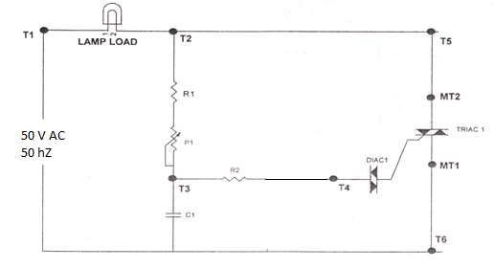
Fig 3.1 AC voltage regulator using TRIAC-DIAC

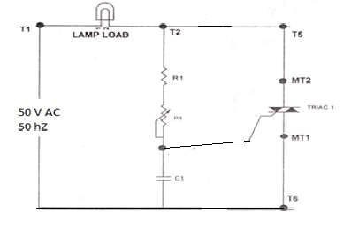
Fig 3.1 shows a TRIAC firing circuit employing DIAC. Variable resistor R controls the charging time of the capacitor C and therefore the firing angle of TRIAC. When R is small, the charging time constant is small, DIAC triggers TRIAC earlier and firing angle is small. Similarly when R is high, firing angle of the TRIAC is large.

Fig 3.2 AC voltage regulator using TRIAC

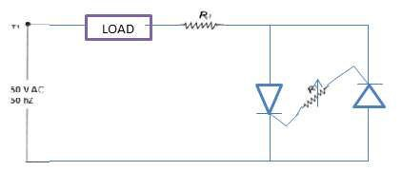
In the circuit 3.1 For waveforms capacitor C2 charges through R1-P1-R2-C2 path in the positive half cycle with upper plate positive with respect of lower plate. When capacitor voltage reaches break –down voltage of DIAC 1(at time t1) DIAC 1 triggers, thus applying gate drive to TRIAC 1 through C2-R3-DIAC1-G-MT1-C2 path and DIAC1 turns ON. R3 is the gate current limiting resistance. Capacitor C2 slowly discharges through above path. At the end of positive half cycle (at time t2) there is some residual voltage on the capacitor C2. In the negative half cycle C2 starts charging in the opposite direction when reverse break over point of DIAC1 is reached (at time t3) it again conduct, in turn turning ON TRIAC 1. The cycle is repeated.

Fig 3.3 AC voltage regulator using antiparallel SCR

Similarly, Fig 3.2 and Fig 3.3 are used as a AC voltage regulator using TRIAC and antiparallel SCR.

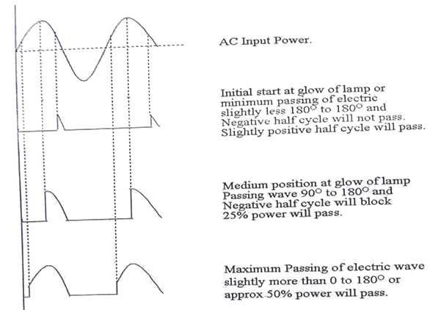

Fig. 3.4 Output waveforms

PROCEDURE:

USING TRIAC AND DIAC:-
- Make the circuit connection as shown in figure.
- Now vary the value of variable resistor to vary the value of firing angle.
- Now connect the CRO probes across the lamp load to observe the variation in the load voltage with the variation in firing angle.
- When we vary the firing angle conduction period of TRIAC varies and hence vary the rms value of ac wave. This variation can be observed by the illumination intensity of load bulb.

USING TRIAC:-
- In the above circuit remove DIAC from T4 & Gate and short circuit the T4 and Gate terminal.

- Now vary the value of variable resistor to vary the value of firing angle.
- Now connect the CRO probes across the lamp load to observe the variation in the load voltage with the variation in firing angle.
- When we vary the firing angle conduction period of TRIAC varies and hence vary the rms value of ac wave. This variation can be observed by the illumination intensity of load bulb.

USING ANTIPARALLEL THYRISTOR:-
- Connect the two thyristor in antiparallel i.e. anode of one thyristor is connected to the cathode of another thyristor (A1 is connected to K2 & K1 is connected to A2).
- A1-K2 terminal is connected to one end of Load bulb and another terminal of load bulb is connected to AC source.
- Another terminal of AC source is connected to the A2-K1 terminal.
- Now a variable resistor is inserted in between the gates of two thyristor G1 & G2.
- If we vary the value of variable resistor the value of firing angle also varies.
- Now connect the CRO probes across the lamp load to observe the variation in the load voltage with the variation in firing angle.

GRAPH
Firing angle v/s AC voltage across load.

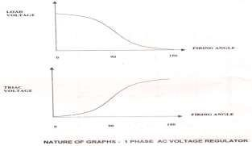

RESULT:-
Thus we have tested and plotted waveforms for AC voltage regulator using TRIAC, Anti parallel SCR and TRIAC & DIAC.
A TRIAC is capable of conducting both in positive and negative cycles of source voltage. So we can regulate the value of AC using firing angle variation. Use of diode provide addition blockage to gate voltage which prevent any access current to flow from gate of TRIAC. And range of angle variation is more when we use a TRIAC instead of Antiparallel thyristor.

DISCUSSION:-
  - Explain features of TRIAC.
  - Compare SCR, TRIAC and DIAC.
  - Mention applications of TRIAC?
  - How do you trigger a TRIAC?
  - What do you mean by AC voltage regulator?
  - What is TRIAC and DIAC output?

EXPERIMENT NO. 4

AIM:-

Study and obtain the waveforms for single-phase bridge converter.

APPARATUS REQUIRED:-

      - Power Project Board

      - CRO 20 MHz

THEORY:-

1-Ø FULL-WAVE CIRCUIT WITH R LOAD:
A single-phase full converter bridge using four SCRs is shown in fig. 4.1(a). The load is assumed to be of R. Thyristor pair T1, T2 is simultaneously triggered and π radians later, pair T3, T4 is gated together. When „a‟ is positive with respect to „b‟, supply voltage waveform is shown as υab in fig. 4.1(b). Where „b‟ is positive with respect to „a‟, supply voltage waveform is shown dotted as υba. Obviously υab = -υba. The current direction and voltage polarities shown in fig. 4.1(a) are treated as positive.
During positive half cycle, Thyristors T1, T2 are forward biased. They get turned- on at ωt = α and source provide its energy to the load in form of dc power through T1, T2. at ωt = π, Thyristors T1, T2 get turned-off because of the line commutation due to the presence of the reverse voltage and current (below holding current) across Thyristors T1, T2. From ωt = π to ωt = π + α, the output voltage is zero because T1, T2 are already off and T3, T4 are yet not turned-on. The T3, T4 are turned-on at ωt = π + α by providing gate pulse at the gate terminal of the SCRs. And the load current io is immediately transferred from T1, T2 to T3, T4, and load voltage υo follows the waveform of the source voltage υs. T3, T4 will conduct from ωt = π + α toωt = 2π. At ωt = 2π, T3, T4 automatically get turned-off due to the reverse voltage across them. In this type of circuit only ac source delivers its energy to the load through thyristor pair which means the load voltage υo and load current io both are positive. As

Thyristors are unidirectional devices due to which load current flows in one direction i.e. it is always positive. The Thyristors T1, T2 are reverse biased from π to 2π, therefore circuit turn- off time is given by-
tc = (2 π - π) / ω = (π / ω) sec.

The T3, T4 are reverse biased from 0° to π, therefore circuit turn-off time is given by- tc = ( π - 0) / ω = (π / ω) sec.
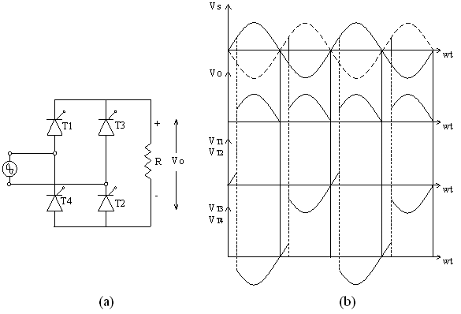

Fig, 4.1 Single-Ø full wave converter with R load; (a) Its circuit diagram and, (b) Its waveforms.

- 1-Ø FULL-WAVE CIRCUIT WITH RL LOAD:- (CONVERSION OPERATION): A single-phase full converter bridge using four SCRs is shown in fig. 4.2(a). The load is assumed to be of RL. Thyristor pair T1, T2 is simultaneously triggered and π radians later, pair T3, T4 is gated together. When „a‟ is positive with respect to „b‟, supply voltage waveform is shown as υab in fig. 4.2(b). Where „b‟ is positive with respect to „a‟, supply

voltage waveform is shown dotted as υba. Obviously υab = -υba. The current direction and voltage polarities shown in fig. 4.2(a) are treated as positive.

Load current or output current io is assumed continuous over the working range; this means that load is always connected to the ac voltage source through the Thyristors. Between ωt = 0° and ωt = α; T1, T2 are forward biased through already conducting SCRs T3 and T4 and blocks the forward voltage. For continuous current, Thyristors T3, T4 conduct after ωt = 0° even though these are reverse biased. When forward biased SCRs T1, T2 are triggered at ωt
= α, they get turned on. As a result, supply voltage Vm sin α immediately appears across thyristor T33, T4 as a reverse bias, these are therefore turned on by natural, or line, commutation. Thyristors T1, T2 conduct from ωt = α to π + α. At ωt = π + α, forward biased SCRs T3, T4 are triggered. The supply voltage turns off T1, T2 by natural commutation and the load current is transferred from T1, T2 to T3, T4. During α to π, both υs and is are positive, power therefore flows from ac source to load. During the interval π to (π + α), υs is negative but is is positive, the load therefore returns some of its energy to the supply system. But net power flow is from ac source to dc load because (π - α) > α. The load terminal voltage, or full-converter output voltage, υo is shown in fig. 4.2(b). The average value of output voltage Vo is given by-
Average voltage (Vo) = (2Vm. cos α)/ π

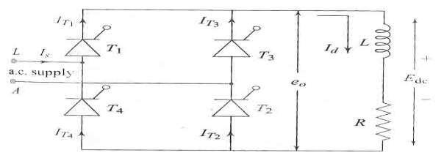

Fig (a)

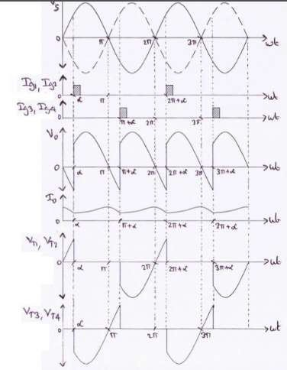

Fig (b)

Fig, 4.2- 1-Ø full wave converter with RL load; (a) Its circuit diagram and, (b) Its waveforms.

- 1-Ø FULL-WAVE CIRCUIT WITH RL LOAD:- (INVERSION OPERATION) When α > 90°, υois negative, which means that the dc load provide energy to the source. This operation can be obtained, when E (emf) is reversed as shown in fig. 4.3(a), this source E will feed power back to ac supply. During positive half cycle, T1, T2 triggered at ωt = α, where α > 90° due to which the load current io flows through the T1, T2 and source. And υo follows the waveform of the υs after the turn–on of the SCRs (T1, T2). But at ωt = π, υo becomes zero but load current io does not become zero due to the presence of the inductor. In this case the emf at load provides dc energy to supply and load current flows through E, T2, supply, T1, and load. During ωt = π to ωt = π + α, the load voltage υo is negative but io is positive. This positive load current io enters in the positive terminal of the supply through T2 which means that the charging of supply is occurred. Therefore, the dc power is converted back into ac power when α > 90° which is known as inversion operation.

Then at ωt = π + α, T3, T4 are triggered due to which load current shifts from T1, T2 to T3, T4.

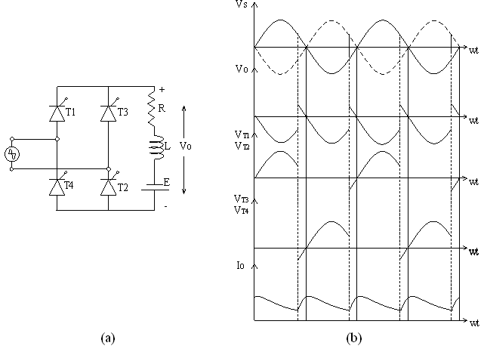

Fig, 4. 3- 1-Ø full wave converter with RL load; (a) Its circuit diagram and, (b) Its waveforms.
During 0° to α, ac source voltage υs is positive but ac source current is is negative, power therefore flows from dc source to ac source. From α to π, both υs and is are positive, power. Therefore flows from ac source to the dc source. But the net power flow is from dc source to ac source, because (π - α) < α in fig. 4.3(b).
In converter operation, the average value of output voltage υo must be greater than load circuit emf E. during inverter operation, load circuit emf E when invented to ac must be more than inverter voltage υo, only then power would flows from dc source to ac supply system. But in both converter and inverter modes, Thyristors must be forward biased and current through SCRs must flow in the same direction as these are uni-junctional devices.
The variation of voltage across Thyristors T1, T2, T3, and T4 reveals that circuit turn-off time for both converter and inverter operations is given by-
tc = [(π - α) / ω]sec.

CIRCUIT DIAGRAM

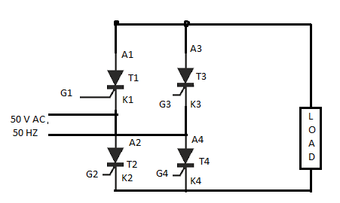

Fig 4.4 Circuit diagram for single phase full wave converter

PROCEDURE:
- Connect the circuit on Power board according the Circuit diagram
- Use R as a load
- Connect G1 and G4 of T1 and T4 to G1 and G2 of the firing circuit and G2 and G3 of T2 and T3 to the G3 and G4 of firing circuit respectively
- Connect the CRO to load
- Switch on the power supply
- By varying the firing angle observe the load voltage.

RESULT:-
  - We have Study and obtain waveforms of 1- Ø full controlled bridge converter with R loads.
  - We have Study and obtain waveforms of 1- Ø full controlled bridge converter with RL loads. Study and show rectification and inversion operation without freewheeling diode.
In single phase full converter there is wider control over the level of dc output voltage. If we make the firing angle Zero we get the output similar to the output which we will get if thyristor is replaced by a diode. We can control the value of output DC voltage by varying the firing angle.

If we use RL load instead of R load then a freewheeling diode is necessary across the load
because current doesn‟t go down instantly.

DISCUSSION:-
    - What is single phase full converter?
    - What is the output voltage of bridge rectifier?
    - What is RLE load ?
    - What do you mean by freewheeling diode?
    - What is meant by phase controlled rectifier?
    - Differentiate between full wave and half wave converter

EXPERIMENT No. 5

AIM:
- ) Study operation of single-phase inverter.
- Study operation of three types of Pulse Width Modulation (PWM) techniques used in single phase inverter.
- Trace the output voltage, carrier signal, reference signal and both gate signal using single PWM of single-phase inverter.

APPARATUS REQUIRED:

Sr. No. | Name of apparatus | Specification | Type | Quantity
1 | Single Phase PWM Inverter Trainer Kit | - | - | 1
2 | Voltmeter | 0-300 V | MI | 1
3 | CRO | 20 MHz | Analog | 1
4 | Power Supply | 1 phase, 230 V,  50 Hz | AC | -

COMPONENTS REQUIRED:

Name of apparatus | Specification | Type | Quantity
Lamp Load | 40/60 Watt | Incandescent lamp | 1

THEORY:
A circuit which converts DC power to AC power at desired output voltage and frequency is known as inverters. The function of inverters is to change a DC input voltage to a symmetrical AC output voltage of desired magnitude and frequency. The output voltage could be fixed or variable frequency. A variable output voltage can be obtained by varying the input DC voltage and maintaining the gain of the inverter constant. On the other hand, if the DC input voltage is fixed and it is not controllable, a variable output voltage can be obtained by varying the gain of

the inverter, which is normally accomplished by pulse-width-modulation (PWM) control within the inverter. The inverter gain may be defined as the ratio of the AC to DC input voltage.
The output voltage waveforms of ideal inverters should be sinusoidal. However, the waveforms of practical inverters are non-sinusoidal and contain certain harmonic. For low and minimum power applications, low distorted sinusoidal waveforms are required. With the availability of high-speed power semiconductor devices, the harmonic contents of output voltage can be minimized or reduce significantly by switching techniques.
Inverters are widely used in industrial applications (e.g., variable speed AC motor drives, induction heating, standby power supplies, and interruptible power supplies). The input may be a battery, fuel cell, solar cell, or other DC source.

Principle of operation:
The principle of single phase inverter can be explained with figure. The inverter circuit consists of two MOSFETs as switch. When only switch S1 is turned on for a time TO/2, V dc/2 appears across the load. The logic circuit should be designed such that S1 & S2 are not turned ON at the same time. Below Fig shows the waveforms for the output voltage with a resistive Load. This inverter requires a three wire DC source, & when a switch is OFF, its reverse voltage is V dc instead of V dc/2. This inverter is known as half bridge inverter.

Voltage control of single phase inverters:
In many industrial applications, it is often required to control the output voltage of inverter:
  - To cope with the variations of DC input voltage,
  - For voltage regulation of inverters, and
  - For the constant volts/frequency control requirement.
There are various techniques to vary the inverter gain. The most efficient method of controlling the gain (output voltage) is to incorporated pulse-width-modulation (PWM) control within the inverters. The commonly used techniques are:
    - Single Pulse Width Modulation
    - Multiple Pulse Width Modulation
    - Sinusoidal Pulse Width Modulation

Single Pulse Width Modulation
In this control there is only one pulse per half cycle & the width of the pulse is varied to control the inverter output voltage. Fig.1 (a) & (b) shows the generation of gating signal & output voltage of single phase half bridge inverters. The gating signals are generated by comparing a rectangular reference signal (saw tooth wave) of amplitude, AR, with a triangular carrier wave (oscillator output wave) of amplitude, Ac. The frequency of the reference signal determines the fundamental frequency of output voltage. By varying AR, from 0 to Ac, the pulse width, δ, can be varied from 0 to 180°. The ratio of AR to Ac is the control variable and defined as the amplitude modulation index.
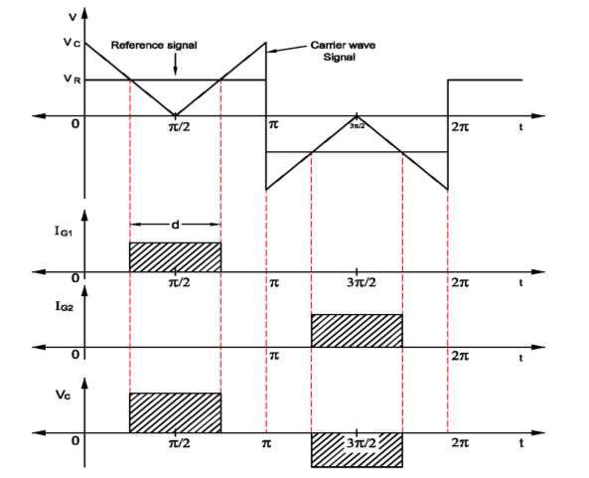
Fig.5.1: Gate signal generation and Output Voltage waveforms of Single Width Modulation inverters

Multiple Pulse Width Modulation

The harmonic content can be reduced by using several pulses in each half cycle of output voltage. The generation of gating signals for turning on and off of transistor is shown in fig.2.3 by comparing a reference signal with a triangular carrier wave. The frequency of reference signal sets the output frequency, FO, and the carrier frequency, FC, determines the number of pulses per half cycle, P. the modulation index controls the output voltage. This type of modulation is also known as uniform pulse width modulation (UPWM).

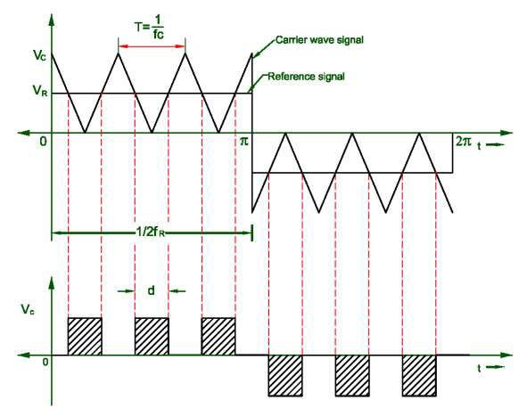

Fig.5.2:Gate signal generation and output voltage waveforms of Multiple Pulse Width Modulation inverters

Sinusoidal Pulse Width Modulation

Instead of maintaining the width of all pulses the same as in the case of multiple pulse modulation, the width of each pulse is varied in proportion to the amplitude of a sine wave evaluated at the centre of the same pulse. The distortion factor and lower order harmonics are reduced significantly.
The gating signals as shown in fig. 4(a) are generated by comparing a sinusoidal reference signal with a triangular carrier wave of frequency, FC. This type of modulation is commonly used in industrial applications and abbreviated as SPWM. The frequency of reference signal, Fr, determines the inverter output frequency, FO, and its peak amplitude, AR, controls the modulation index M, and then in turn the RMS output voltage, Vo.

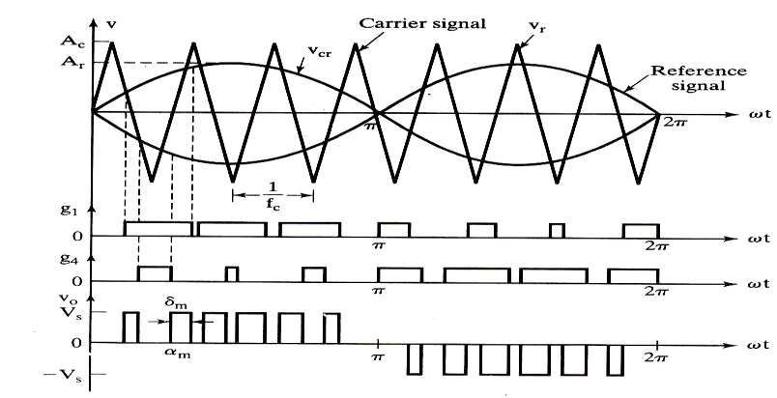

Fig. 5.3: Gate signal generation and output voltage waveforms of Sinusoidal Pulse Width Modulation

PROCEDURE:
- Ensure frequency and pulse width control pots P1 and P2 respectively are in most anticlockwise position. also ensure that switch 1 in normal position and load is connected.
- Switch ON the main power supply.

- Observe the waveforms with the help of CRO at TP1 for saw-tooth wave, TP2 for oscillator pulses, TP3 for output for gate2 and TP4 for output for gate 1 with respect to ground.
- Observe the effect of frequency control pot P1 and pulse width control P2 on the waveforms observed in 3.
- Now place a link between DC supply and inverter input through the link points E.

- Output of the inverter can be varied with help of pulse width control Pot P2.

- CRO is connected across TP5 and TP6 for observe the waveforms for low voltage side of the AC voltage generated.
- For study of current limiting operation, 0-5 amp. DC ammeter must be connecting properly instead of the link patch cord.
- Pot P3 rotate anticlockwise, the current limit can be observed at 2 amp, 1.5 amp, 1 amp, etc. pot P3 rotate fully clockwise when finish this study.
- Remove the input power supply.

- If want to check system with battery operation, connect the 12 V battery between E terminal ( + ve) and ground.
- Place a link for battery operation for 12 V DC supply.

- Observe the waveforms across terminal TP5 and TP6.

- Remove both the links and battery after finish the experiment.

RESULT:
Thus we have studied and the single phase inverter and different types of PWM techniques used in single phase inverter and traced the output voltage, carrier signal, reference signal and both gate signal of single phase inverter.

DISCUSSION:
- What is the function of inverter? Mention different categories of commercial inverter.

- What is meant by carrier wave form in PWM control?

- What are the control strategies for inverter?

- What are the advantages of PWM inverter?

- What is the condition for ideal inverter operation?

- What are the applications of PWM inverter?

EXPERIMENT NO.-6

AIM: To observe and verify the operation of buck, boost and buck-boost regulators.

APPARATUS REQUIRED:-

S. No | Name of Apparatus | Specifications | Quantity
1 | Buck, Boost, Buck- boost converters trainer kit | - | 1
2 | DC voltmeter | 0-50V | 1
3 | CRO | 20MHz | 1
4 | AC power supply | single phase, 230V-50Hz | 1
THEORY:-

Buck converter

A buck converter is a step-down DC to DC converter. It is a switched-mode power supply that uses two switches (a transistor and a diode), an inductor and a capacitor.

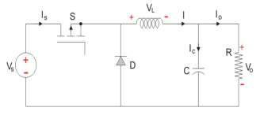

Fig.6.1 Buck converter The Buck converter has two modes of operation:
- Mode I: Switch is ON, Diode is OFF

- Mode II: Switch is OFF, Diode is ON
Mode I: Switch is ON, Diode is OFF

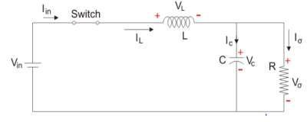

Fig.6.2 Buck converter: Switch is ON, Diode is OFF

When the switch is first closed, the current will begin to increase, but the inductor opposes increase in current by dropping a voltage. This voltage drop counteracts the voltage of the source and therefore reduces the net voltage across the load. Over time, the inductor will allow the current to increase slowly by decreasing the voltage and therefore increasing the net voltage seen by the load. During this time, the inductor is storing energy in the form of a magnetic field.
The voltage across the capacitance in steady state is equal to the output voltage. Let us say the switch is on for a time TON and is off for a time TOFF.
We define the time period, T, as T=TON+TOFF and the switching frequency is given by fswitching=1/T. Now, a very important term is the duty cycle, which is denoted by D= TON/T.
Mode II: Switch is OFF, Diode is ON

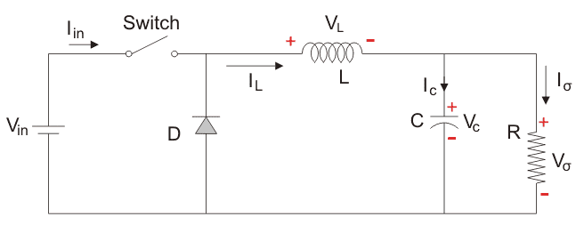
Fig.6.3 Buck converter: Switch is OFF, Diode is ON
The key principle that drives this mode is the tendency of an inductor to resist changes in current.

If the switch is opened before the inductor has fully charged (i.e., before it has allowed all of the current to pass through by reducing its own voltage drop to 0), then there will always be a voltage drop across it, so the net voltage seen by the load will always be less than the input voltage source.
When the switch is opened again, the inductor is discharging its stored energy into the rest of the circuit and acting like a voltage source
If the switch is closed again before the inductor fully discharges, the load will always see a non- zero voltage. The capacitor placed in parallel with the load helps to smooth out voltage waveform as the inductor charges and discharges in each cycle.
Buck converters are remarkably efficient (95% or higher for integrated circuits), making them useful for tasks such as converting the main voltage in a computer (12 V in a desktop, 12-24 V in a laptop) down to the 0.8-1.8 volts needed by the processor.

Boost converter

A boost converter (step-up converter) is a DC-to-DC power converter with an output voltage greater than its input voltage. It is a class of switched-mode power supply (SMPS) containing at least two semiconductor switches (a diode and a transistor) and at least one energy storage element, a capacitor, inductor, or the two in combination. Filters made of capacitors (sometimes in combination with inductors) are normally added to the output of the converter to reduce output voltage ripple.

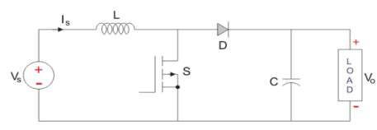

Fig.6.4: Boost converter

Boost converter operates in two modes: Mode I : Switch is ON, Diode is OFF

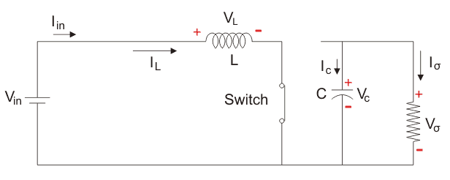

Fig.6.5: Boost converter: Switch is ON, Diode is OFF

The Switch is ON representing a short circuit ideally offering zero resistance to the flow of current so when the switch is ON, all the current will flow through the switch and back to the DC input source
Mode II: Switch is OFF, Diode is ON

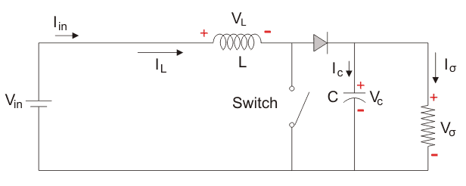

Fig.6.6: Boost converter: Switch is OFF, Diode is ON

In this mode, the polarity of the inductor is reversed. The energy stored in the inductor is released and is ultimately dissipated through the load resistance, and this helps to maintain the

flow of current in the same direction through the load and also step-up the output voltage as the inductor is now also acting as a source in conjunction with the input source.
If the switch is cycled fast enough, the inductor will not discharge fully in between charging stages, and the load will always see a voltage greater than that of the input source alone when the switch is opened.
Also while the switch is opened, the capacitor in parallel with the load is charged to this combined voltage. When the switch is then closed and the right hand side is shorted out from the left hand side, the capacitor is therefore able to provide the voltage and energy to the load. During this time, the blocking diode prevents the capacitor from discharging through the switch. The switch must be opened again fast enough to prevent the capacitor from discharging too much.

Buck–boost converter

The buck–boost converter is a type of DC-to-DC converter that has an output voltage magnitude that is either greater than or less than the input voltage magnitude.

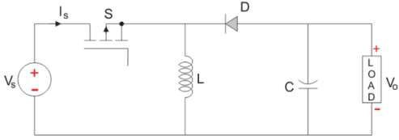

Fig.6.7:Buck–boost converter

Principle of Operation

- In On-state, the input voltage source is directly connected to the inductor (L). This results in accumulating energy in L. In this stage, the capacitor supplies energy to the output load.

- In the Off-state, the inductor is connected to the output load and capacitor, so energy is transferred from L to C and R.
Compared to the buck and boost converters, the characteristics of the buck–boost converter are mainly:
  - polarity of the output voltage is opposite to that of the input;
  - The output voltage can vary continuously from 0 to (for ideal converter). The output voltage ranges for a buck and a boost converter are respectively 0 to Vi and Vi to .

PROCEDURE:-

For buck converter

- Keep AC voltage selection switch in T2.

- Keep P4 in most anticlockwise position.

- Keep selector switch on P1.

- Now connect test point marked as R1 to the test point marked as R1 on buck configuration.

- Connect PSC1 (+ve) to PSC1 in buck configuration.

- Now check the connection before switch ON the system.

- Now slowly increase POT P4 in clockwise direction and observe the output carefully.

For boost converter

- Keep AC voltage selection switch in T2.

- Keep P4 in most anticlockwise position.

- Keep selector switch in P2.

- Now connect test point marked as R1 to the test point marked as R1 on boost configuration.

- Connect PSC1 (+ve) to PSC1 in boost configuration.

- Now check the connection before switch ON the system.

- Now slowly increase POT P4 in clockwise direction and observe the output carefully.

For Buck- boost converter

- Keep AC voltage selection switch in T2.

- Keep P4 in most anticlockwise position.

- Keep selector switch in P2.

- Now connect test point marked as R1 to the test point marked as R1 on buck-boost configuration.
- Connect PSC1 (+ve) to PSC1 in buck-.boost configuration.

- Now check the connection before switch ON the system.

- Now slowly increase POT P4 in clockwise direction and observe the output carefully.

- Observe that for lower P4 value, it will work as buck converter and above certain value, it will work as boost converter.

OBSERVATION TABLE:-

Buck regulator

S.No. | Vin | VOUT
1
2
3
4

Boost regulator

S.No. | Vin | VOUT
1
2
3

4

Buck- Boost regulator

S.No. | Vin | VOUT
1
2
3
4
5

RESULT:-

Thus, we have observed the output voltage of Buck, Boost and Buck-Boost regulators and verified their operation.

DISCUSSION:-

- What do you mean by continuous and discontinuous mode of operation of these regulators?

- What are the applications of buck-boost converter?

- Why we require SMPS even if phase controlled rectifiers are available?

- Write the expression of output and input voltage for boost converter.

- Given a buck converter with input voltage to be 15 V from a 100W source, and have an output current of 4 A. Assuming no power losses determine: average input current, output voltage, duty ratio. The filter inductance is 100 µH and the switching frequency is 10 kHz. Will this converter be in continuous conduction?

EXPERIMENT NO.-7

AIM: To control speed of a DC motor using a chopper and plot armature voltage versus speed characteristic.

APPARATUS REQUIRED:

Sr. No. | Name of apparatus | Specification | Type | Quantity
1 | Buck, Boost and Buck- Boost Regulators Trainer Kit | - | - | 1
2 | Voltmeter | 0-50 V | MC | 2
3 | CRO | 20 MHz | Analog | 1
4 | Power Supply | 1 phase, 230 V,  50 Hz | AC | -

THEORY:

A buck converter is a step-down DC to DC converter. This buck converter also acts as DC chopper because DC chopper is also a DC-DC converter.

CIRCUIT DIAGRAM:

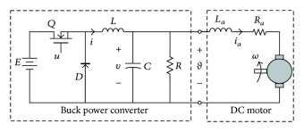
Fig.7.1: DC motor speed control using buck converter

Operating principle:

When the switch in the buck regulator is on, the voltage that appears across the inductor is Vi - Vo. Using the inductor equations, the current in the inductor will rise at a rate of (Vi-Vo)/L. At this time the diode D is reverse biased and does not conduct.

When the switch opens, current must still flow as the inductor works to keep the same current flowing. As a result current still flows through the inductor and in to the load. The diode, D then forms the return path with a current I diode equal to Io flowing through it.
With the switch open, the polarity of the voltage across the inductor has reversed and therefore the current through the inductor decreases with a slope equal to -Vo/L. We will connect DC shunt motor at the output of buck converter. Now, we will first focus on basic characteristics of DC motor.
The back EMF for a DC motor is given by,

Eb=pфnz/60A

Here n is the no. of poles, p is the armature conductors, z is the no. of parallel paths, A is constant for a particular machine, ф is the supply phase.
Speed of motor, N=K*(Eb/ф) = K*(V-IaRa)/ф

The equation for the speed of the motor clearly indicates the following:

  - Speed of the dc motor can be controlled above the normal range of speed by varying the resistance in the armature circuit included in the form of aerostat as a variable resistance (armature control).
  - Speed of the DC motor can be controlled above the normal range of speed by decreasing the flux or by decreasing the current in the field circuit by including as external resistance in the form of a rheostat as variable resistance (field control).

ARMATURE CONTROL:

Let the external resistance in the armature circuit or DC shunt motor be R ohms, then the speed equation modifies to,
N=K*(V-IA (RA+R))/ф RPM
Hence the speed of the motor decreases with an increase in the value of external resistance R. thus reduce speed lower than the no load speed can be obtained by this method. However, there is an excessive wastage in the additional resistance, which lowers the efficiency of the motor considerably.

FIELDCONTROL

The speed of the DC motor can be increased beyond the no load speed by increasing an external resistance in the shunt field circuit.
The current in the external resistance is very low; hence the losses occurring in the additional resistance is quite small.

PROCEDURE:

- Connect the DC motor as per the circuit diagram shown in attached sheet.
- Ensure that the external resistance in the armature circuit to be maximum.
- Ensure that the external resistance in the field current is minimum.
- Start the DC motor through dc starter this is done to provide safety to armature control rheostat.
- After starting the dc motor through starter now vary the armature control rheostat and measure the corresponding voltage across armature terminals till the rated voltage.
- Cut out the external resistance in the armature circuit and adjust the field current, so that the motor becomes rated speed.
- The field current is kept constant to the above value varying the voltage applied to the armature by varying the external resistance in the armature circuit. Record the applied voltage and the corresponding speed.

- Repeat step 6 for various values of applied voltage to the armature, till the rated voltage of the motor.
- Keep the applied voltage to the armature constant at its rated value. Varying the speed of the motor by inserting external resistance in the field circuit. Record the field current and the corresponding speed of the motor.
- Repeat step 8 for various value of field currents, till the speed of the motor is about 1.4 times the rated of the motor it is not advisable to increase the speed beyond 1.4 times the rated speed , otherwise mechanical stresses will be high, which may damage the motor. Hence the field current should not be decreased to a very low value.
- Switch off the main supply to stop the motor.

OBSERVATION TABLE:

Armature control |  |  | Field control
S. No. | Applied voltage | Speed | S. No. | Field control | Speed

GRAPH:

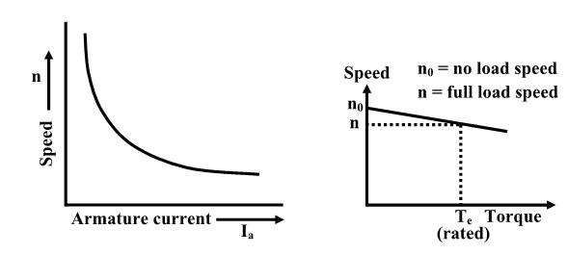

RESULT:-Hence, the speed of dc motor is controlled using a DC chopper and graph between armature voltage & speed is plotted successfully.

DISCUSSION:

- What type of commutation is applied to DC chopper?

- Give the commutating element to form the commutating circuit for the main thyristor?

- How the load current can smoothen at the output?

- Give the torque equation of DC machine.

- Test the speed control of DC motor using boost converter.

- Test the speed control of DC motor using boost converter.

EXPERIMENT NO.8

AIM:- To control speed of a single-phase induction motor using single phase AC voltage regulator.

APPARATUS REQUIRED:-

  - Power Project Board

  - CRO 20 MHz

  - Single Phase Induction Motor

  - Tachometer

THEORY:-

AC voltage regulator (controller) is a device which converts fixed alternating voltage to variable Alternating voltage without changing frequency. By connecting a reverse parallel pair of thyristors, DIAC or TRIAC between AC supply and load, the motor load can be controlled. This type of power controller is known as AC voltage controller or AC regulators. The firing of a TRIAC can be phase controlled. Since DIAC exercised in both directions the power in the load can be varied from full value to almost zero. The DIAC in the circuit gives a wide range of symmetrical firing of the TRIAC. The resistance R1 control the Gate current by controlling the voltage across C. Here the voltage across C first turns on the DIAC which in turns applies enough voltage to the Gate to turn on the TRIAC.
By property matching the DIAC to the TRIAC symmetrical triggering of the TRIAC in both the positive and negative alternations is accomplished. Moreover, the range of firing control is much wider so that a turn on delay of almost 1800 is possible in each alternation.
The circuit however shows some hysteresis i.e. the power applied to the load does not vary in the same manner when the direction of rotation of R1 is reversed.
The important applications where AC voltage controllers are widely used are: speed control of induction motors, domestic and industrial heating, light controllers, ON load transformer tap changing, static reactive power compensators etc.

Since the AC regulators are phase controlled converters, thyristors and TRIACs are line commutated and as such no complex commutation circuitry is required in these controllers.

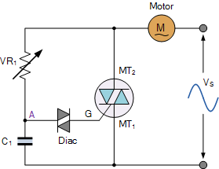

Fig. 8.1: Speed control circuit of induction motor using TRIAC-DIAC

Fig.1 shows a TRIAC firing circuit employing DIAC. Variable resistor R controls the charging time of the capacitor C and therefore the firing angle of TRIAC. When R is small, the charging time constant is small, DIAC triggers TRIAC earlier and firing angle is small. Similarly when R is high, firing angle of the TRIAC is large.

PROCEDURE:
- Make the circuit connection as shown in figure 1.
- Vary the value of variable resistor to vary the value of firing angle.
- Now, connect the CRO probes across the motor load to observe the variation in the load voltage with the variation in firing angle.
- When we vary the firing angle, conduction period of TRIAC varies and hence vary the rms value of ac wave.
- Measure the speed of induction motor using tachometer carefully.

OBSERVATIONS:

S. No | Variable Resistance(ohms) | Speed (rpm)
1
2
3
4

RESULT:-
Thus, we have tested and plotted waveforms for AC voltage regulator using TRIAC & DIAC.

DISCUSSION:-

- What is the basic working equation of induction motor?
- Test the speed control of induction motor using TRIAC only.
- Test the speed control of induction motor using antiparallel thyristors only.
- How firing angle of TRIAC depends upon the value of variable resistor?
- Which type of firing circuit is efficient of this voltage regulation?
- List different applications of AC voltage regulation.

EXPERIMENT NO.- 9
AIM: (i) To obtain the output waveforms for single phase dual converter using R and L loads
(ii) Study speed control of DC motor using single phase dual converter.

APPARATUS/ COMPONENTS REQUIRED: -

S.N | Name of the equipment | Range | Quantity
1 | Dual Converter Kit |  | 1
2 | C.R.O |  | 1
3 | Connecting probes |  | as required
4 | R load | 0-200 ohm/ 5A | 1
5 | L load (center tapped) | 0-300mH/5A | 1
6 | Isolation transformer |  | 1

THEORY:
Dual converter- the name itself indicates that it has two converters in it. It is an electric device mostly found in variable speed drivers. It is a power electronics control system to get either polarity DC from AC rectification by the forward converter and reverse converter. In a dual converter, two converters are connected together back to back.
One of the bridge works as a rectifier (converts AC to DC), another half bridge works as an inverter (converts DC to AC) and connected commonly to a DC load. Here two conversion processes take place simultaneously, so it is called as a dual converter. The dual converter can provide four quadrant operations as in Fig.9.1

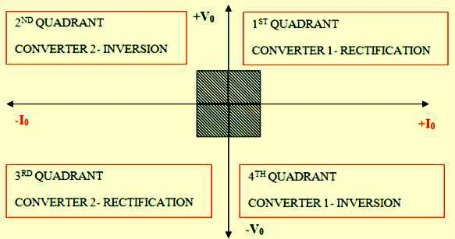

Fig.9.1. Quadrants of operation

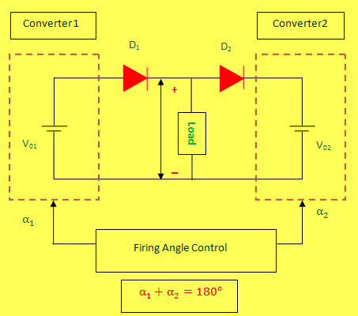
Fig.9.2 Block diagram of dual convertor

The dual converter is a power electronics control system to get either polarity DC from AC rectification by the forward converter and reverse converter. It can run DC motors in either direction with speed control too. This single phase converter is achieved by using a pair of a thyristor controlled bridge (4 SCRs X 2) that enables the DC motor to get reversed polarity for

either direction rotation and speed control also lowered in steps by Microcontroller triggering each bridge SCR bank of duly interfaced through Opto-isolators.

CIRCUIT DIAGRAM

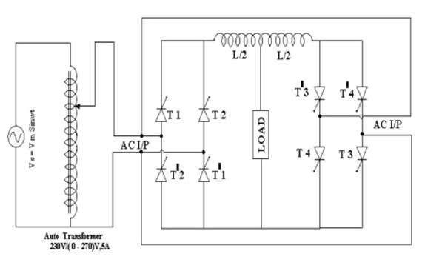
Fig.9.3 Circuit diagram of dual convertor

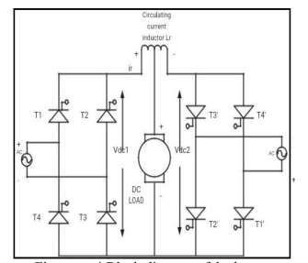

PROCEDURE :
Fig.9.4 Load replaced by DC motor

(For R and L loads)

- Make all connections as per the circulatory circuit diagram.
- Connect R-load across load terminals.
- Connect the input AC supply to the power circuit through an Isolating Transformer (take input voltage 30V)
- Select the CC/NCC (circulating/non circulating current mode) mode in firing circuit.
- Give the firing pulses and keep P-converter in ON position and also put on the MCB switch.
- By varying the firing angle observe related output waveforms in the CRO.Tabulate all the readings.
- Repeat all above procedure for RL-load.

(For motor control)

  - Connect the mains plug 3- pin top to 230V AC mains socket.
  - Keep SPEED / ALPHA potentiometer at ZERO.
  - Keep FWD / REV switch to FWD position.
  - Connect the Jone‟s plug 4-pin top of motor in the output female socket tightly. [Pin 1&2 = ARM]
  - Put a 15 W lamp in the backside load holder. This is a dummy load essential for latching current to SCRs better observation of waveform.
  - Switch ON the mains (SW1) rocker switch, Rocker Switch glows.
  - Press start button, observe all control test point voltage & waveform on CRO.
  - Wait for motor response. Increase SPEED / ALPHA pot clock wise. Observe the motor running in clockwise direction.
  - Decrease the speed and press the stop button. Motor stop slowly due to kinetic energy.
  - Observe different waveforms on an UNEARTHED CRO with line trigger mode and two long probes to suit the test points.
  - Change the direction switch to REV position & repeat the same procedure.
  - Observe motor running in anticlockwise direction.

  - Draw the waveforms of control & power circuit test points.
  - To avoid any short circuit do not observe power waveforms VA, VF, IA simultaneously. Do not observe control & power waveforms simultaneously.
  - Follow the instruction of the teaching staff member while taking observation or performing any other experiment using additional volt and current meter wattmeter, load bench, speedometer, etc.
  - Fill following observation table.

OBSERVATIONS:

(For R and L loads)

S.No | Input Voltage (V in) | Firing angle in Degrees | Output voltage (V0) |  | Output Current (I0)
1 |  |  | Theoretical | Practical | Theoretical | Practical
2
3
4
5
6
7

(For motor control)
Vary the „speed‟ by SPEED POT from position „0‟ to „10‟ in steps & note the following readings
using External tachometer, True RMS meter and current meter.

POT POSITION | O/P VOLTAGE | O/P CURRENT | SPEED
Nos. | DC Volts | DC Amps | RPM
Dial
0
1

2
.
.
10

RESULT:
Hence we have studied the single phase dual converter and studied the speed control of DC motor using single phase dual converter.

DISCUSSION:-
- What is the four quadrant operation of convertor?
- What will happen if the firing angle is greater than 90 degrees?
- What is the use of SCR in convertor circuit?
- If firing angle is greater than 90 degrees, the inverter circuit formed is called as?
- What are advantages of dual converter?
- What are the drawbacks of the dual converter?

EXPERIMENT NO.-10
AIM: To verify the operation of single phase Cyclo Converter with R and RL Loads and to observe the output and input waveforms

APPARATUS/ COMPONENTS REQUIRED: -

S.N | Name of the equipment | Quantity
1 | Single phase center tapped transformer | 1
2 | Single phase cycloconverter power circuit with firing unit | 1
3 | Rheostat | as required
4 | Inductive load | 1
5 | Voltmeter | 1
6 | CRO with (1:10) probe | 1
7 | Patch cord | 1 set

THEORY:
In industrial applications, two forms of electrical energy are used: direct current (dc) and alternating current (ac). Usually constant voltage constant frequency single-phase or three-phase ac is readily available. However, for different applications, different forms, magnitudes and/or frequencies are required. There are four different conversions between dc and ac power sources. These conversions are done by circuits called power converters. The converters are classified as: 1-rectifiers: from single-phase or three-phase ac to variable voltage dc.
- choppers: from dc to variable voltage dc.
- inverters: from dc to variable magnitude and variable frequency, single-phase or three phase ac.

- cycloconverters: from single-phase or three-phase ac to variable magnitude and variable frequency, single-phase or three-phase ac.
This article explains what Cycloconverters are, their types, how they operate and their applications.
Traditionally, ac-ac conversion using semiconductor switches is done in two different ways: 1- in two stages (ac-dc and then dc-ac) as in dc link converters or 2- in one stage (ac-ac) cycloconverters (Fig. 10.1). Cycloconverters are used in high power applications driving induction and synchronous motors. They are usually phase-controlled and they traditionally use SCR

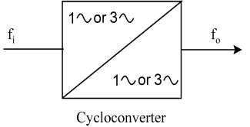
Fig.10.1 Cycloconverter

Single-phase to Single-phase (1ph-1ph) Cycloconverter:
To understand the operation principles of cycloconverters, the single-phase to single-phase Cycloconverter (Fig. 2) should be studied first. This converter consists of back-to-back connection of two full-wave rectifier circuits. Fig.10.3 shows the operating waveforms for this converter with a resistive load. The input voltage, VS is an ac voltage at a frequency, fi as shown in Fig. 3a. For easy understanding assume that all the SCR are fired at 0 firing angle, i.e. SCR act like diodes. Note that the firing angles are named as αp for the positive converter and αN for the negative converter. Consider the operation of the cycloconverter to get one-fourth of the input frequency at the output. For the first two cycles of VS,the positive converter operates supplying current to the load. It rectifies the input voltage; therefore, the load sees 4 positive half cycles as seen in Fig. 10.3b. In the next two cycles, the negative converter operates supplying current to

the load in the reverse direction. The current waveforms are not shown in the figures because the resistive load current will have the same waveform as the voltage but only scaled by the resistance. Note that when one of the converters operates the other one is disabled, so that there is no current circulating between the two rectifiers.
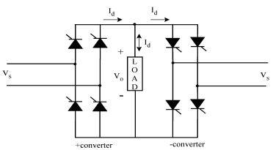
Fig.10.2 Single-phase to single-phase cycloconverter

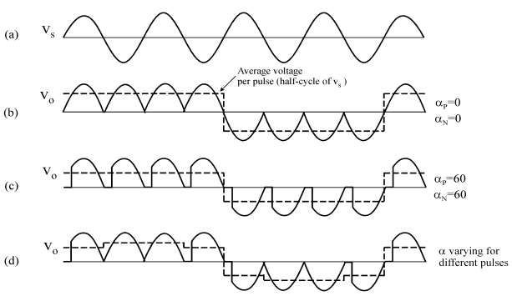
Fig.10.3 Single-phase to single-phase cycloconverter waveforms a) Input voltage b) Output voltage for zero firing angle c) Output voltage with firing angle p/3 rad d) Output voltage with varying firing angle

The frequency of the output voltage, VO in Fig. 10.3b is 4 times less than that of VS, the input voltage, i.e. fo/fi=1/4. Thus, this is a step-down cycloconverter. On the other hand, cycloconverters that have fo/fi>1 frequency relation are called step-up cycloconverters. Note that step-down cycloconverters are more widely used than the step-up ones.
The dc output of each rectifier is:

Where, V is the input rms voltage.
√ 𝑜 …(1)

Then the peak of the fundamental output voltage is

√ 𝑜 ………(2)

Equation 2 implies that the fundamental output voltage depends on a. For a=0°,
X1=
If a is increased to p/3 , then

√

𝑝
Thus the fundamental output voltage can be controlled. Constant αN operation gives a crude
output waveform with rich harmonic content. The dotted lines in Fig. 10.3b and c show a square wave. If the square wave can be modified to look more like a sine wave, the harmonics would be reduced.

CIRCUIT DIAGRAM

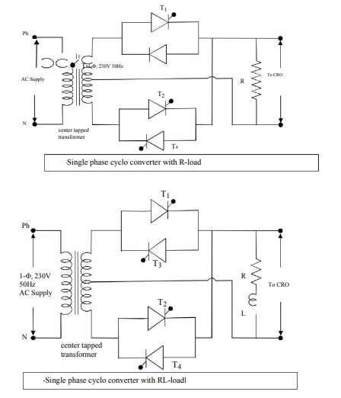

PROCEDURE:
A) For R-Load:
Fig.10.4 Circuit diagram for cyclconvertor

- Connect the circuit as shown in figure. 10.4
- Verify the connections from the lab instructor before switch on the supply.
- Keep the rheostat position value given by the lab instructor
- Switch ON the supply and note down the frequency of input voltage from the CRO.

- Set the frequency division switch at 2 and note the readings of time period of output voltage waveform for different set of firing angles
- Calculate the practical value of output frequency by reciprocating the value of time period and theoretical value of frequency will be found from frequency division setting
- Repeat the above process from step 5 to 6 for frequency division of 3 and 4.

B).For RL-Load:
- Connect the circuit as shown in figure.10.4
- Connect an inductance of given value in series with the load resistance.
- Verify the connections from the lab instructor before switch on the supply.
- Keep the rheostat position value given by the lab instructor
- Switch ON the supply and note down the frequency of input voltage from the CRO.
- Set the frequency division switch at 2 and note the readings of time period of output voltage waveform for different set of firing angles
- Calculate the practical value of output frequency by reciprocating the value of time period and theoretical value of frequency will be found from frequency division setting
- Repeat the above process from step 5 to 6 for frequency division of 3 and 4

OBSERVATIONS
- For R load
Input voltage Vph=……………..V
Value of load resistance RL =……………..Ω Input frequency=…………….Hz

S.No | Frequency division | Firing angle in degree(α) | Time period(ms) | Frequency(Practical) | Frequency(Theoretical)
1
2
3
4

5

- For RL load
Input voltage Vph=……………..V
Value of load resistance RL =……………..Ω
Value of Load inductance=…………….mH

S.No | Frequency division | Firing angle in degree(α) | Time period(ms) | Frequency(Practical) | Frequency(Theoretical)
1
2
3
4
5

RESULT:
Hence we have successfully observed the waveform of single phase cycloconvertors for R and RL load.
We also compare the theoretical frequency and practical frequency for R and RL load.

DISCUSSION:-
  - Which commutation is employed in cycloconverter.
  - Give the applications of cycloconverter.
  - Describe the effect on distortion on output frequency of cycloconverter?
  - What is meant by hybrid operation of cycloconverter?
  - Give the advantages and disadvantages of cycloconverter.

EXPERIMENT NO:- 11

AIM: - Perform experiment on Motor control – open loop &closed loop using PID Controller

APPARATUS/ COMPONENTS REQUIRED: -
DC motor speed controller using PID mode (CE-28A)

THEORY: -
This DC motor speed control system is designed to demonstrate the application of PID control mode for DC motor. The unit is self-contained. 24V, 1A DC motor mounted on a fixed base and provided loading arrangement. The speed of the motor made variable with the help of Pot P1.The armature voltage is derived from a regulated DC power supply 35V, 3A capacity. The unit is provided with analog ammeter (0 - 1A range).The front panel of the system having various controls for the study of the system with open loop and closed loop mode. In closed loop we can study the system performance with proportional mode, P+I mode and P+I+D mode. The potentiometer for proportional gain, integral time constant and derivative time constant are provided on the system.
The reference speed can be varied by using Pot P1. The same reference Pot is also associated with a soft start arrangement to avoid sudden start of the system. In the open loop mode we can observe that at set speed if we apply a load the speed of the system decreases. But in closed loop mode, even if load increases the speed of the system is constant. Thus the entire system enables to observe the effect of load variations on the system performance. In the open loop the system operates in the range 200-1500rpm and in closed loop the system operates 200- 900rpm with maximum current of 800mA.

PROCEDURE: -

Operating instructions for open loop operation:
      - Before you switch on the unit please study all the controls on the panel and try to understand their functions also.

      - Keep SW1 in upward positions i.e. in open loop positions
      - Keep SW2 in upward positions i.e. in normal positions
      - Keep SW3 in upward positions i.e. in start positions
      - Start the motor with the help of pot P1 at reference 10 (i.e. ADC value) indicated by LCD.
      - Set the speed 1500 rmp max. At 1500 rpm motor takes 200mA current i.e. no load current.
      - Apply a load (in the range 200-800 mA max) and enter the reading in tabular form. Open loop mode set speed = 1500 rpm
S.no | Current(mA) | Actual speed (rpm)
1 | 200 (no load)
2 | 300
3 | 400
4 | 500
5 | 600
6 | 700

Close loop with proportional action:
      - Keep SW1 in lower positions i.e. in close loop positions
      - Keep SW2 in lower (mode check) positions & set the proportional gain Kp at 105. Then keep the SW2 at higher (normal) position.
      - Keep SW3 in upward positions i.e. in start positions
      - Start the motor with the help of pot P1 from 150-200rpm above and set he speed at 850 rpm indicated by LCD
      - Apply a load (in the range 200-800 mA max) and enter the reading in tabular form.

Proportional mode Kp=105Set speed = 850rpm

S.no | Current(mA) | Actual speed (rpm)
1 | 100 (no load)
2 | 200
3 | 300
4 | 400
5 | 500
6 | 600
7 | 700
8 | 800

    - Close loop with proportional + integral (P+I) action:
      - Keep SW1 in lower positions i.e. in close loop positions
      - Keep SW2 in lower (mode check) positions and set the proportional gain Kp at 105 & Ki
= 1 by pot P2 and P3 respectively. Then keep the SW2 at higher (normal) position.
      - Keep SW3 in upward positions i.e. in start positions
      - Start the motor with the help of pot P1 from 150-200rpm above and set he speed at 850 rpm indicated by LCD
      - Apply a load (in the range 200-800 mA max) and enter the reading in tabular form. Proportional + Integral mode Kp=105 & Ki = 1 Set speed = 850rpm
S.no | Current(mA) | Actual speed (rpm)
1 | 100 (no load)
2 | 200
3 | 300
4 | 400
5 | 500
6 | 600
7 | 700
8 | 800

Close loop with proportional + integral + derivative (P+I+D) action:-
      - Keep SW1 in lower positions i.e. in close loop positions.
      - Keep SW2 in lower (mode check) positions & set the proportional gain Kp at 105 &
Ki = 1 &kd =4 by pot P2, P3 and P4 respectively. Then keep the SW2 at higher position.
      - Keep SW3 in upward positions i.e. in start positions
      - Start the motor with the help of pot P1 from 150-200rpm above and set The speed at 850 rpm indicated by LCD
      - Apply a load (in the range 200-800 mA max) and enter the reading in tabular form. Proportional + Integral + derivative mode Kp=105 & Ki = 1 &Kd = 4 Set speed = 850rpm
S.no | Current(mA) | Actual speed (rpm)
1 | 100 (no load)
2 | 200
3 | 300
4 | 400
5 | 500
6 | 600
7 | 700
8 | 800

RESULT: -Thus PID control mode offers good transient response and no offset error.

DISCUSSION:-
- What are the different speed control methods?
- Difference between field control and armature control method.
- Why speed control is necessary.
- What is speed regulation?
- What will happen, with increase in speed of DC motor?
- What is back EMF?

EXPERIMENT NO:- 12
AIM:- Design, observe and perform experiment on various type of pulse generation from DSP/ FPGA Platform. Perform experiment for PWM inverters and choppers.

APPARATUS/ COMPONENTS REQUIRED: -
PC, TMS320C6713 DSK, Code composer Studiov3.0

THEORY: -
The TMS320C6713 DSP Starter Kit (DSK) developed jointly with Spectrum Digital is a low- cost development platform designed to speed the development of high precision applications based on TI´s TMS320C6000 floating point DSP generation.
The C6713 DSK tools include the latest fast simulators from TI and access to the Analysis Toolkit via Update Advisor which features the Cache Analysis tool and Multi-Event Profiler. Using Cache Analysis developers improve the performance of their application by optimizing cache usage. By providing a graphical view of the on-chip cache activity over time the user can quickly determine if their code is using the on-chip cache to get peak performance. The DSK features the TMS320C6713 DSP, a 225 MHz device delivering up to 1800 million instructions per second (MIPs).
A programmable logic device called a CPLD is used to implement glue logic that ties the board components together. The CPLD has a register based user interface that lets the user configure the board by reading and writing to the CPLD registers. The registers reside at the midpoint of CE1. The DSK includes 4 LEDs and 4 DIP switches as a simple way to provide the user with interactive feedback. Both are accessed by reading and writing to the CPLD registers. An included 5V external power supply is used to power the board. On-board voltage regulators provide the 1.26V DSP core voltage, 3.3V digital and 3.3V analog voltages. A voltage supervisor monitors the internally generated voltage, and will hold the boards in reset until the supplies are within operating specifications and the reset button is released. If desired, JP1 and JP2 can be used as power test points for the core and I/O power supplies. Code Composer communicates with the DSK through an embedded JTAG emulator with a USB host interface.

The DSK can also be used with an external emulator through the external JTAG connector. The figure below shows the peripheral description of DSK 6713.
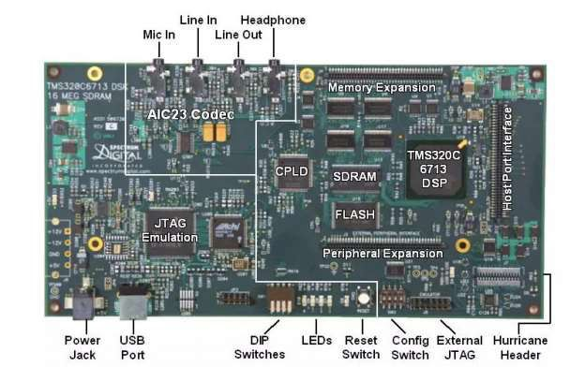
Fig.12.1 Peripheral description of DSK 6713

Generation of Sine Waveform using DSP Kit
The sine wave or sinusoidal wave is a mathematical curve that describes smooth repetitive oscillations. It can be represented in mathematical form as
Y(t)= A sin(ω t+ ϕ)
where A=Amplitude in V. ω=angular frequency ϕ=Phase in radians.

Algorithm:
- Define frequency in C program.
- Generate the signals using corresponding general formula.
- Plot the graph in Code Composer Studio.

Procedure for Sinusoidal wave form generation:
- Open Code Composer Studio; make sure the DSP kit is turned on.
- Start a new project using „Project-new „pull down menu, save it in a separate directory with a
name.
- Add the source files sine wave.c to the project using „Project→add files to project→pull down menu.
- Add the linker command file hello.cmd
- Add the run time support library file rts6700.lib
- Compile the program using the „Project-compile‟ pull down menu or by clicking the shortcut
icon on the left side of program window.
- Build the program using the „Project-Build‟ pull down menu or by clicking the shortcut icon on the left side of program window.
- Load the program (sine wave.out) in program memory of DSP chip using the „File-load program‟ pull down menu.
- To View output graphically Select view→graph→time and frequency.

Program for sine wave generation: sine wave.c
#include<stdio.h>
#include<math.h>
#define freq 400 float m[128]; main()

{int n=0; for(n=0;n<127;n++)
{m[n]= sin(2*3.14*freq*n/24000)
printf(“ %f ”,m[n]);
}
}
Thus, the waveform generation of sine wave is performed in Code composer environment by using a C program. Output will be displayed in the graphical window of CCS software as shown below.
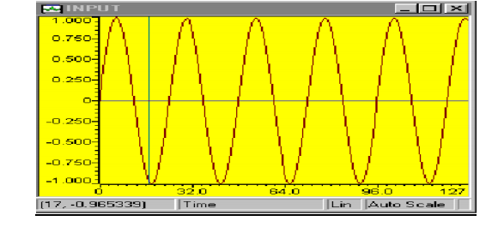

Fig.12.2 Sine wave generated
RESULT: The waveform generation of sine wave is performed in Code composer environment by using a C program.

DISCUSSION:-
  - How a sine wave signal is defined.
  - How can we control inverters and choppers by varying pulse width.
  - Basic writing of a C program.
  - Explain some features of DSP kit used
  - What changes have to be done in code to generate a cosine wave.

EXPERIMENT NO:- 13

AIM: - Study and obtain the characteristic of DIAC. APPARATUS/ COMPONENTS REQUIRED: - DIAC (SSD3A)
Ammeter (0-100mA) Voltmeter (0-50 V) Resistor (5K Ω,1K Ω)
Bread Board, Connecting wires

THEORY: -
A DIAC is a two terminal three layer bidirectional device which can be switched from its off state to on state for either polarity of applied voltage. The operation of DIAC is identical both in forward and reverse conduction. The DIAC does not conduct until the applied voltage of either polarity reaches the break over voltage VBO.

Characteristic of DIAC: Forward Direction

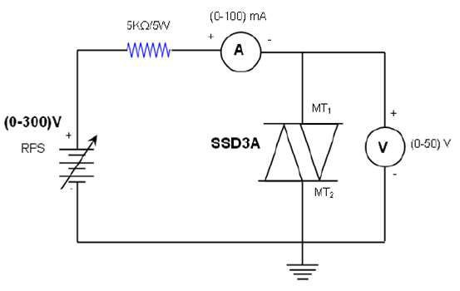

Reverse Direction

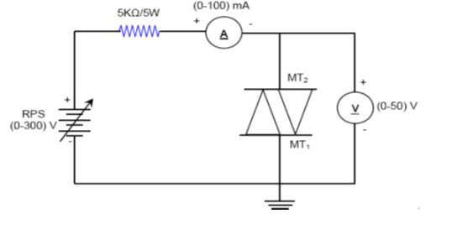
Fig.13.1 DIAC in Forward and Reverse mode

Characteristic Curve

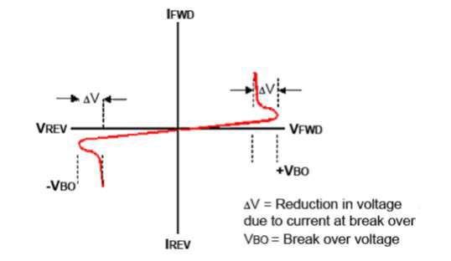

PROCEDURE: -
DIAC Characteristics:
Fig. 13.2 Characteristic Curve of DIAC

- The connections are made as shown in the circuit diagram.
- First DIAC is connected in forward direction
- The input supply is increased in step by step by varying the RPS
- The corresponding ammeter and voltmeter readings are noted
- Then the DIAC is connected in reverse condition.

- The above process is repeated.

OBSERVATION:

S.No | Forward direction |  | Reverse direction
S.No | Voltage (V) | Current (mA) | Voltage (V) | Current (mA)

RESULT:
Thus the V-I characteristics of DIAC is obtained and graph is drawn.

DISCUSSION:
- What is DIAC, how is it different from SCR
- Why there is no requirement of Gate terminal in DIAC
- Compare the breakdown voltage of DIAC with SCR
- Write down the applications where DIAC is used in the circuit
- How does DIAC conduct in both forward and reverse directions.

EXPERIMENT NO:- 14
AIM: Study of single phase half wave controlled rectifier using R- load and RL – load.

APPARATUS/ COMPONENTS REQUIRED: -
Thyristor (TYN612) CRO
Multimeter Resistor Connecting Wires

THEORY:

Single-Phase Half-Wave Controlled Rectifier using R - load
The single-phase half-wave controlled rectifier uses a single thyristor with a load and also the output voltage and current waveform as shown in figure 1. In a positive half cycle of source
voltage ( = 𝑚 𝑥 𝑛 𝜔 ), thyristor is forward biased and when gate current iG is applied to
the gate terminal at firing angle α then thyristor strarts to conduct. The output voltage will appear
from ωt = α to ωt = π. At ωt = π, thyristor goes turned OFF. In a negative half cycle, ωt = π to ωt
= 2π, thyristor is reverse biased and output voltage is zero during this period. Therefore, by changing the value of firing angle (α) the output voltage can be controlled. The average output voltage is given by:
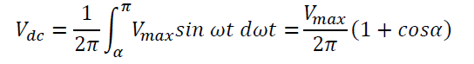
And rms value of output voltage is given by,

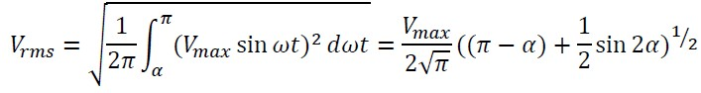

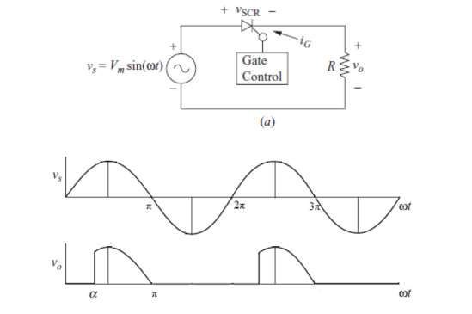

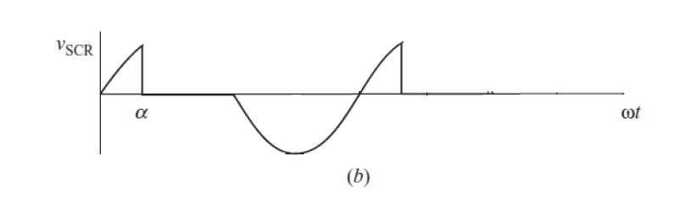

Fig.14.1 Single Phase half wave controlled rectifier with resistive load

Single-Phase Half-Wave Controlled Rectifier using RL – load
The single-phase half-wave controlled rectifier uses a single thyristor with a RL load and aslo the output voltage and current waveform as shown in figure 2. In a positive half cycle of source
voltage ( = 𝑚 𝑥 𝑛 𝜔 ), thyristor is forward biased and when gate current iG is applied to
the gate terminal at firing angle α then thyristor starts to conduct. The output voltage will appear
from ωt = α to ωt = π. At ωt = π, thyristor goes turned OFF but current does not decay to zero because of the energy stored in inductor. The negative voltage will appear from ωt = π to ωt = β. The load current decays to zero at ωt = β and value of β depends upon the ratio R/L. During ωt =

β to ωt = 2π, the output voltage is zero during this period. The angle β is called extinction angle and γ = (β – α) is called conduction angle.
The average value of output voltage is given by,

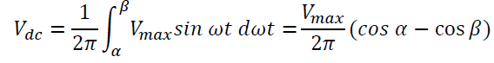
And the rms voltage is given by

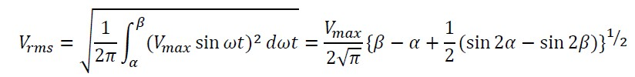

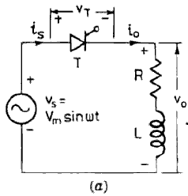

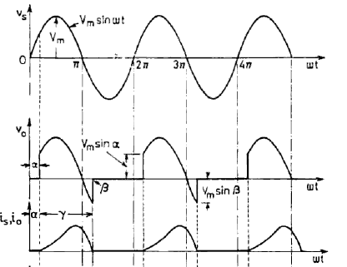

Fig, 14.2 Single phase half wave controlled rectifier with resistive-inductive load

OBSERVATION
- Input Parameter
  - Input voltage …………..
  - Frequency .…………..
  - Cycle time period ...…………
- Observation Table :

Half wave controlled rectifier with R – load

S.No | Triggering time(t) | Firing angle(α) | Observed output voltage |  | Theoretical output voltage
S.No | Triggering time(t) | Firing angle(α) | Avg voltage | RMS  voltage | Avg voltage | RMS voltage
1
2
3
4
5
6

Half wave controlled rectifier with RL – load

S.No | Triggering time(t) | Firing  angle(α) | Observed output voltage |  | Theoretical output voltage |  | Extinction Angle(β)
S.No | Triggering time(t) | Firing  angle(α) | Avg voltage | RMS  voltage | Avg voltage | RMS  voltage | Practical | Theoretical
1
2
3
4
5
6

RESULT: The RMS voltage and average voltage depends on the type of load which is used. A negative peak in RMS voltage is obtained for RL load.

DISCUSSION:
- What will be the change in waveform when diode is used in place of SCR
- What is the firing angle for diode
- What is the effect of increasing load resistance on waveform
- What is the effect of using R-L load in place of R load on waveform
- What is the difference between firing angle and extinction angle

